AN EXHIBIT · REVISED & ANNOTATED EDITION
The Reinvention of
the City of New York
FROM NEW AMSTERDAM TO THE 51ST STATE — A DOCUMENTARY EXHIBIT
Revised & annotated edition of the original exhibit
With corrections, citations & historical illustrations
Original preserved in Part V · Every claim examined

CONTENTS
(This edition is structured in six parts. In Word, References → Table of Contents can regenerate a live TOC from the headings below.)

PART 0
ABOUT THIS EDITION
“The past is never dead. It’s not even past.”
— William Faulkner, Requiem for a Nun (1950)
IN THIS PART
- What this edition is — and what it is not
- How to read the corrections, citations & claim reviews

READER'S GUIDE
About This Edition
This document began as a research exhibit that weaves together four centuries of New York history — the Lenape homeland, Dutch New Amsterdam, English New York, and a quixotic 1969 campaign to make the five boroughs the 51st state — together with legal theories about jurisdiction, seals, and cityhood that circulate in legal-reform circles today.
It is presented here in a revised and annotated edition. The history has been verified and enriched with deep research and illustrations. The legal theories are presented exactly as the original states them, then documented for what they are: a distinct school of thought with a long paper trail — and a uniformly negative one — in the courts.
What this edition does
- Preserves every substantive element of the original exhibit. Nothing has been silently dropped.
- Corrects factual errors (the title garble, dates, case names) in a running series of correction panels and a consolidated register.
- Adds deep research: the 1969 election results and aftermath, the full statehood precedent, Dutch-era detail, verified genealogy, and the 2020 Supreme Court ruling the original anticipated.
- Documents contested legal claims with their provenance and court treatment, without endorsement.
A note on the original document
The original exhibit carries the title “1625: The 1973 Reinvention of The City of New York as 51st State” — a garbled line whose halves each point at something real: the year 1625 (when New Amsterdam was designated the province's capital and Fort Amsterdam's site staked out) and a date in the 1970s (when the city re-dated its own seal). This edition restores the readable form and logs every such fix.
HOW THE CITATIONS WORK
Numbered citations [1], [2] … point to Notes & Sources at the end of this document, keyed to the exact URLs consulted during research.
Claims that could not be independently verified are marked [unverified] rather than smoothed over.
Where the original exhibit and the record disagree, both readings are shown — the original’s text is never altered without notice.

PART 1
THE ISLAND
“Lenapehoking — the island of many hills, in the estuary of the long water.”
— after the Lenape name for their homeland
IN THIS PART
- The megalopolis & the Lenape homeland
- Verrazzano 1524 · Gomes 1525 · Hudson 1609
- 1624–1626: Fort Amsterdam & New Amsterdam
- Minuit's purchase, wampum & the beaver crash
- Kieft's War, Stuyvesant, and the bloodless surrender of 1664

PART I · CHAPTER 1
The Island at the World's Edge
Before it was New York — before it was New Amsterdam — the harbor region was Lenapehoking, homeland of the Lenape and their Algonquian kin. The exhibit's opening survey, verified and expanded.
New York, often called New York City (NYC), is the most populous city in the United States, located at the southern tip of New York State on New York Harbor. Its five boroughs — Manhattan, Queens, Brooklyn, the Bronx and Staten Island — are each coextensive with a county. It anchors both the Northeast megalopolis and the New York metropolitan area, the largest in the United States by population and urban area, and hosts the headquarters of the United Nations. [38]
In the pre-Columbian era the region was inhabited by Algonquian peoples including the Lenape, whose homeland Lenapehoking spanned Staten Island, Manhattan, the Bronx, western Long Island (including Brooklyn and Queens) and the lower Hudson Valley. [28]
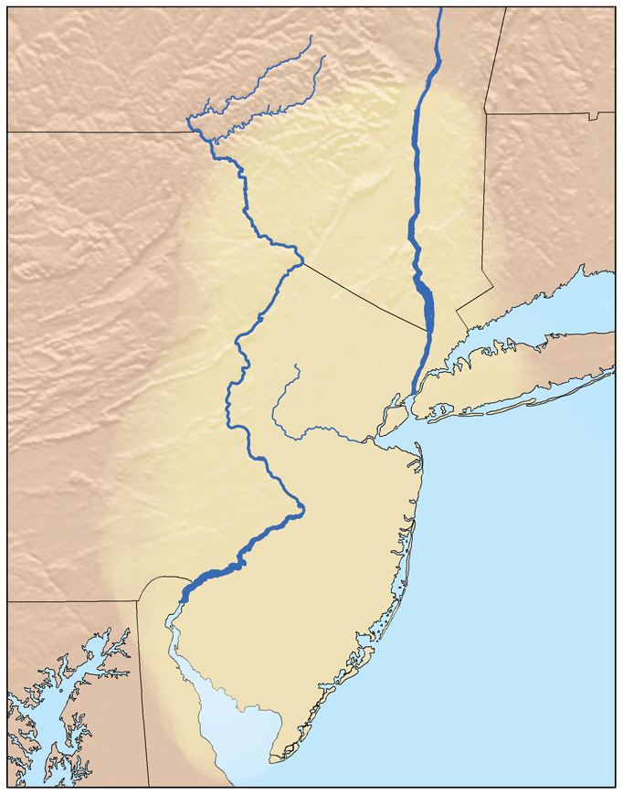
Lenapehoking — the Lenape homeland at the eve of European contact · No machine-readable author provided. Kmusser assumed (based · CC BY-SA 2.5 · Wikimedia Commons
The European arrival
The first documented European visit to New York Harbor was in 1524 by Giovanni da Verrazzano, who claimed the area for France as Nouvelle Angoulême. A Spanish expedition under the Portuguese captain Estêvão Gomes, sailing for Emperor Charles V, arrived in January 1525 and charted the mouth of the Hudson, naming it Río de San Antonio. [47]
In 1609 Henry Hudson, an Englishman sailing for the Dutch East India Company, entered the harbor while searching for the Northwest Passage and sailed up the river the Dutch called the South River or North River — today's Hudson. [35]
1624–1626: forts, families, and the first New Yorkers
A permanent European presence began in May 1624, when the Nieu Nederlandt landed thirty families — most of them Protestant Walloons — on Noten Eylandt (Governors Island), “the landing place of the first settlers in New Netherland.” [37][39] That same year eighteen Walloon settlers built Fort Orange (near today's Albany) as replacement for flood-prone Fort Nassau (1614). [42][32] In 1625 New Amsterdam was designated the capital of the province, its site staked out directly south of today's Bowling Green; Fort Amsterdam itself rose at the spot from 1626. [25][36]
The first documented non-Native resident of Manhattan was Juan Rodriguez, a merchant from Santo Domingo who arrived in 1613 and stayed, trapping and trading as the Dutch representative. [28]
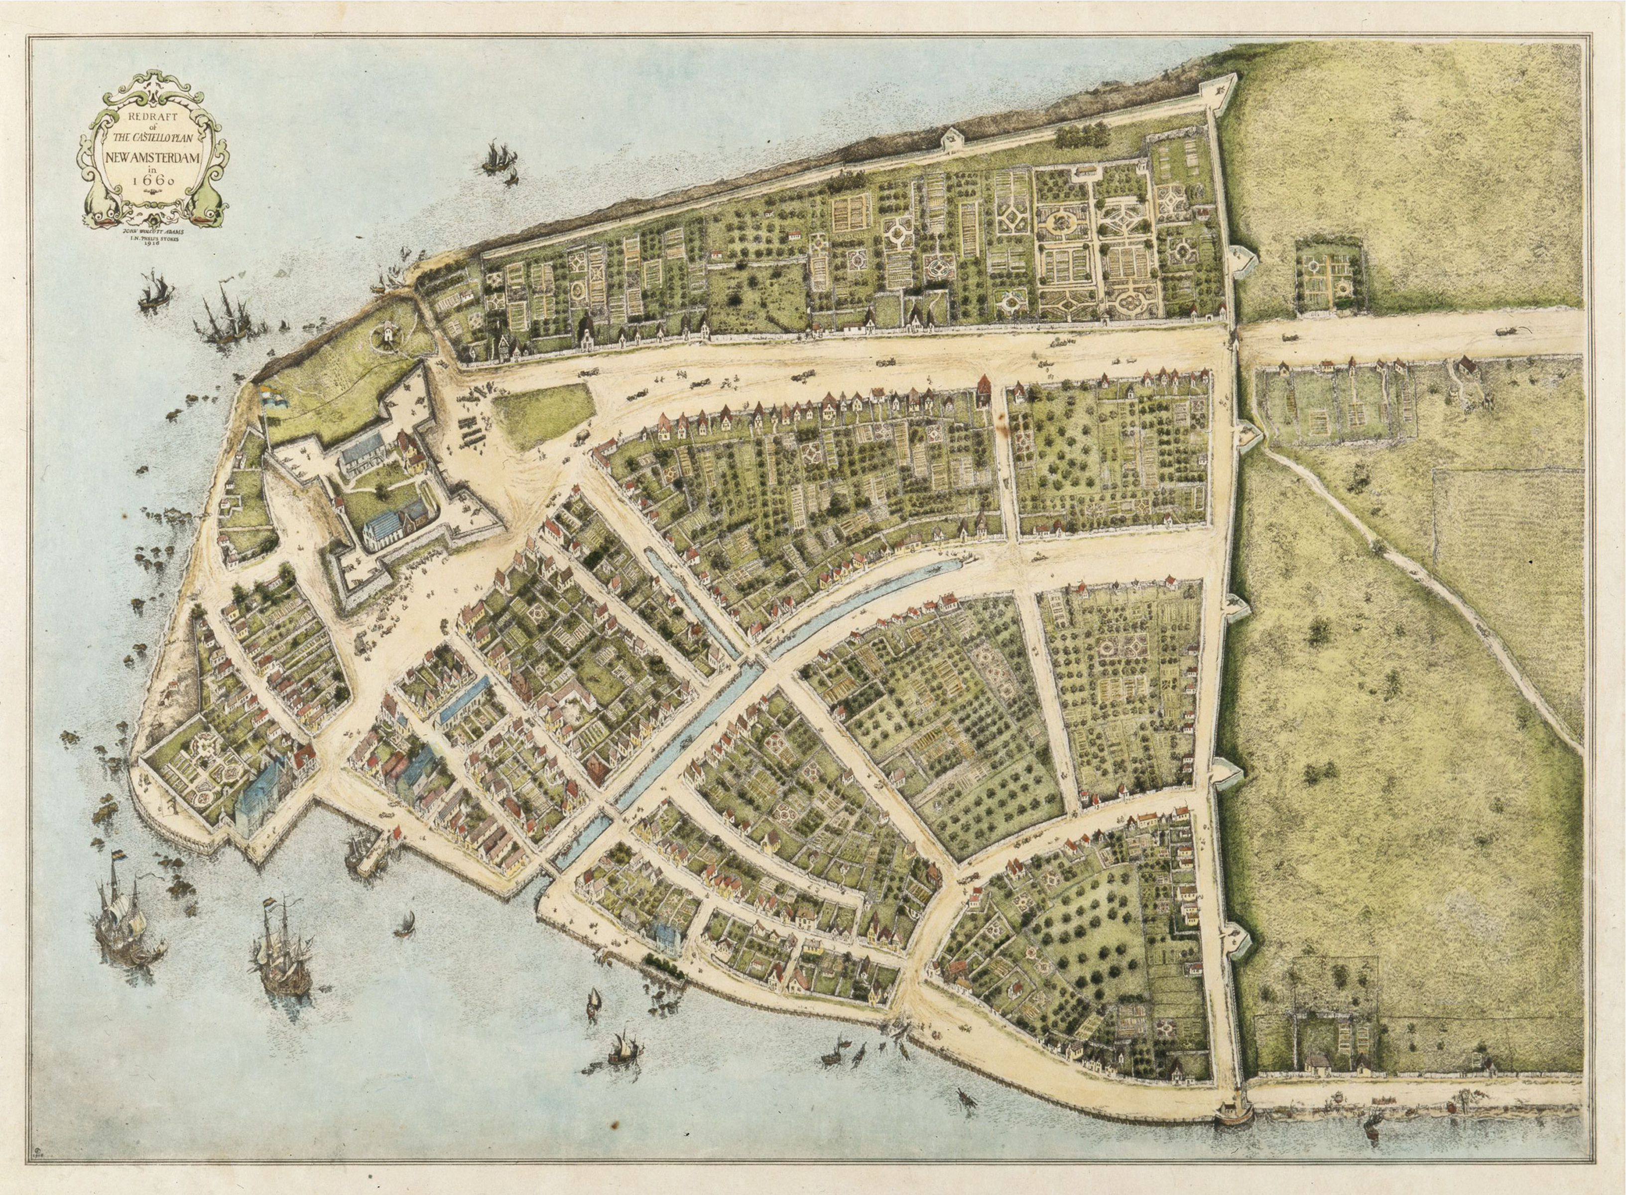
The Castello Plan (1660) — the oldest detailed map of New Amsterdam, drawn on the eve of the English takeover · John Wolcott Adams · Public domain · Wikimedia Commons
The town's street plan survives in the Castello Plan of 1660. The original wall — a 12-foot wooden stockade built in 1653 against Native and English raids — gave Wall Street its name and stood until 1699. [25] The colony of New Amsterdam then extended from the southern tip of Manhattan to roughly that line.
CORRECTION — the original title garble
Original: “1625: The 1973 Reinvention of The City of New York as 51st State”.
Correction: The title fuses unrelated years. 1625 = New Amsterdam designated capital of New Netherland. The seal-date legislation belongs to 1975 and 1977 (two separate local laws — Part II). The “51st State” is the 1969 Mailer–Breslin campaign (Part III). No reinvention happened in 1973.

The Minuit purchase of 1626
On May 24, 1626, Peter Minuit — born c. 1580–1585 in Wesel, a Walloon merchant — arrived as the West India Company's new Director-General and that year arranged the acquisition of Manhattan for traded goods valued at 60 guilders. The only near-contemporary record is the Peter Schaghen letter of 1626, reporting the purchase from “the Indians.” [26] The famous “$24 in beads” figure is a 19th-century conversion: historian John Romeyn Brodhead translated 60 guilders into $24 in 1844; modern equivalents run from about $1,000 (2006) to $1,143 (2020). [26]
The counterparty is its own story: the Canarsee, who “are credited with selling the island of Manhattan to the Dutch, even though they only occupied its lower reaches” — the land was mostly controlled by the Weckquaesgeek, so the Dutch bought from sellers who did not hold the whole of what they sold. [44] And the meaning differed on each side: to the Lenape, land “sale” likely read as a sharing-and-trade agreement rather than an irreversible transfer of title.
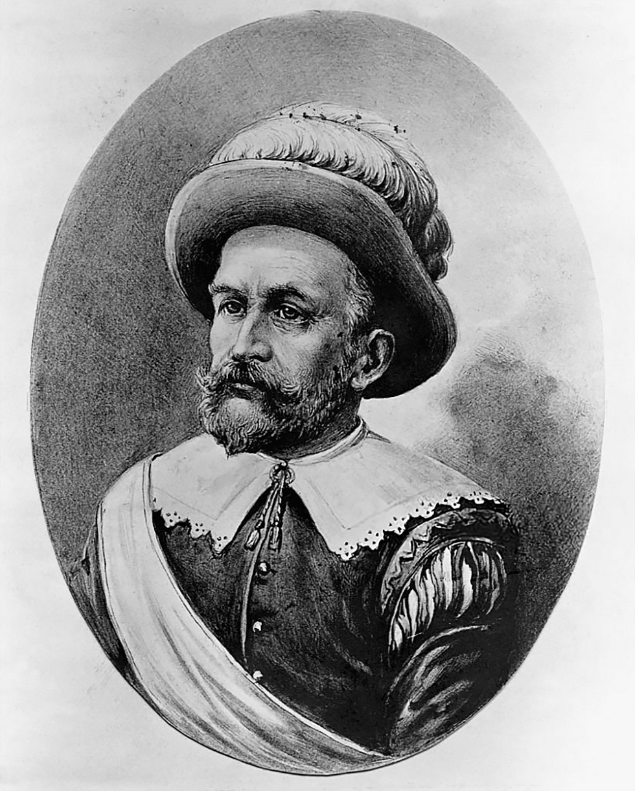
Peter Minuit (Minnewit) — Director-General who arranged the 1626 acquisition of Manhattan · Unknown · Public domain · Wikimedia Commons
Wampum and the beaver crash
The Dutch leveraged indigenous reliance on wampum — strings and belts of shell beads — as a trading medium, exchanging metal tools for beaver pelts. Tooled-up indigenous producers made wampum faster, debasing it; Lenape men shifted from subsistence hunting toward beaver trapping; the Dutch began manufacturing their own wampum to dominate the network. Within two decades beavers were largely trapped out of the five boroughs, leaving the Lenape dependent on Dutch trade while disease, starvation and forced migration cut the population through the 17th century. [35]
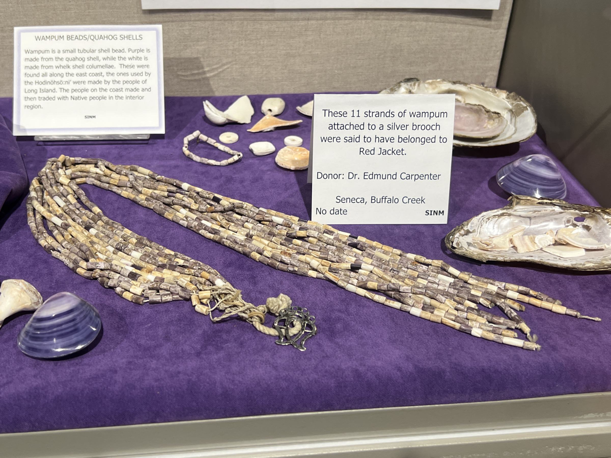
Wampum — shell-bead trade medium of the Northeast woodlands · Nosferattus · CC0 · Wikimedia Commons
Kieft's War and the surrender of 1664
Willem Kieft, director-general from 1638, embroiled the colony in Kieft's War (1643–45). On the night of February 25, 1643, colonists descended on the camps at Pavonia across the Hudson (today's Jersey City) — sources count roughly 80 to 120 people killed there, and about 40 more at Corlear's Hook the same night. [40][60] In response, eleven Algonquian tribes proclaimed open war and nearly defeated the colony; Dutch reinforcements from Europe broke the resistance, and a truce came in August 1645. [61]
CORRECTION — the Pavonia death toll
Original: “resulted in the death of eighty Indigenous in February 1643.”
Correction: “Eighty” sits at the low end of the record. The Public History Project counts “at least 80 people… killed at Pavonia, and 40 at Corlear's Hook”; contemporaneous accounts run to 120 at Pavonia. This edition reports the full range — 80–120 at Pavonia plus ~40 at Corlear's Hook — rather than the single low figure. [60][40]

Peter Stuyvesant, the last director-general (1647–1664), ruled a colony whose population grew from roughly 2,000 to 8,000 under his administration — though by 1664 New Amsterdam itself held about 2,500 of the colony's nearly 9,000. [29][59][35] Despotic but effective, he regulated liquor, clashed with the Dutch Reformed Church, blocked rival congregations — and was unpopular with the merchants he governed.
When four English frigates under Colonel Richard Nicolls sailed into the harbor in August 1664, Stuyvesant wanted to fight; his council and the city did not. He capitulated by signing the Articles of Surrender, and on September 8, 1664, the West India Company's colors were struck without a shot fired. [48][38] The town was reincorporated under English law and renamed New York; Thomas Willett was appointed the first mayor in June 1665, “with the approval of the English and Dutch alike.” [31]
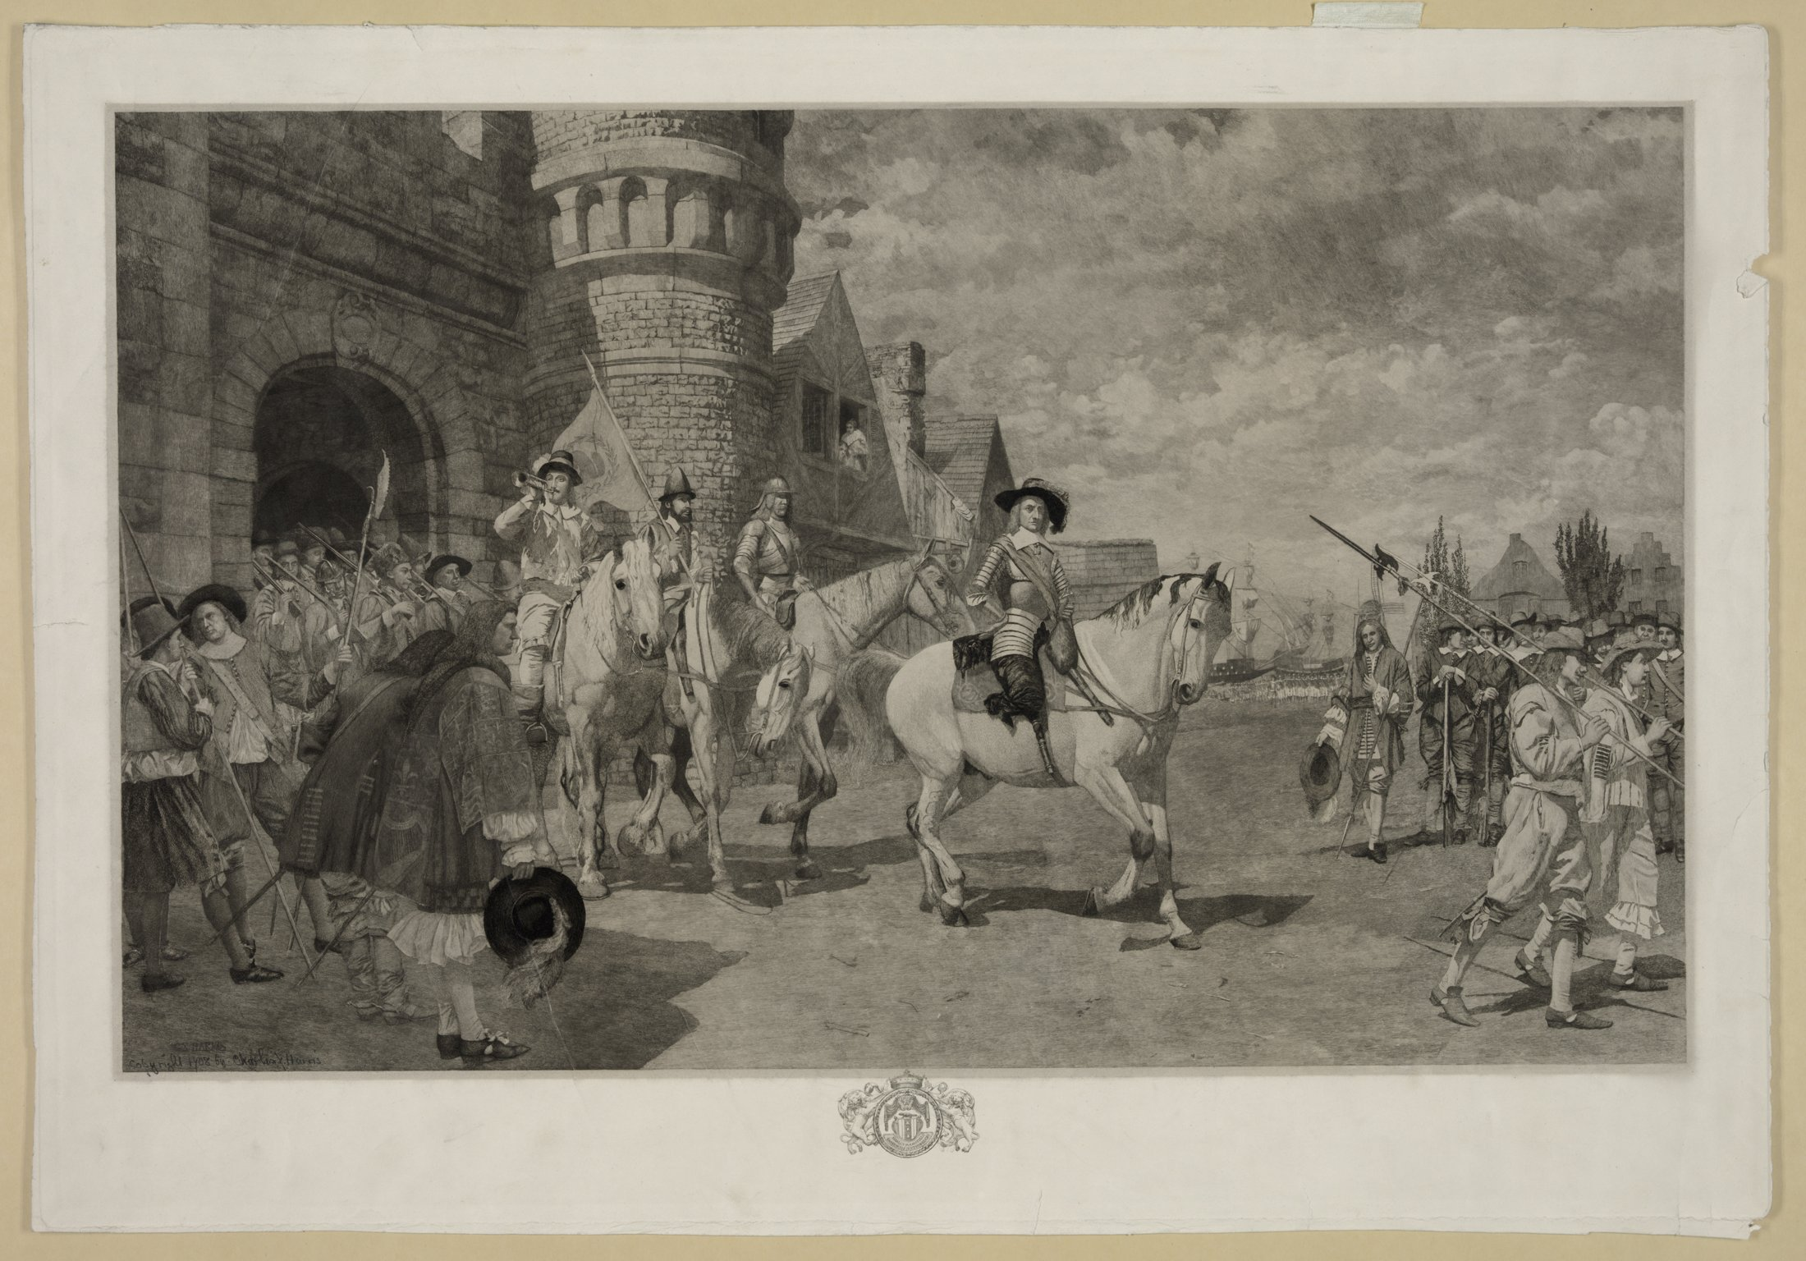
The surrender of New Amsterdam, September 8, 1664 — depicted in a later historical painting · Harris, Charles X., 1856-, etcher · Public domain · Wikimedia Commons
The Dutch were not finished. In 1667 the Treaty of Breda ended the Second Anglo-Dutch War in a Dutch victory — but the colony remained English by its terms. [30] In August 1673, during the Third Anglo-Dutch War, Anthony Colve seized the city and rechristened it New Orange; the Treaty of Westminster (February 1674) handed it back, and the Dutch presence passed into street names. [35][41]
THE DUTCH STREET MAP — names that survived the flag
The Dutch origins survive in the city's names: Coney Island (likely from konijn, rabbit), Bowery (bouwerij, farm), Brooklyn (Breukelen, a Utrecht town), Harlem (Haarlem, formalized as Nieuw Haarlem in 1658), Greenwich Village (Groenwijck, “green district”), Flushing (Vlissingen), Staten Island (Staaten Eylandt). [{CONEY}][{BOWERY}][{BREUKelen}][{HARLEM}][{GREENWICHVIL}][{FLUSHING}][{NEWNETHERLAND}]

PART 2
SEALS & SYMBOLS
“Sigillum Civitatis Novi Eboraci — the seal is the city's signature.”
— after the city seal's Latin legend
IN THIS PART
- The Great Seal of New York State — heraldry explained
- The city flag: Dutch tricolor, Prince's Flag origins, 1915
- 1975 & 1977: the two laws that re-dated the city
- Sarah Rapelje — first child of New Netherland

PART II · CHAPTER 1
Seals, Flags, and a City Arguing About Its Birthday
The original exhibit spends its middle section on heraldry — the state seal's blazon, the armiger entry, and a fierce argument about the year inscribed on the city seal. Here the record is unusually rich, and unusually testable.
The Great Seal of the State of New York
The original exhibit reproduces the heraldic specification of the state coat of arms — an eagle surmounting a globe (the Atlantic hemisphere), a shield with the sun rising over the Hudson, the supporters Liberty and Justice, the motto Excelsior. The arms were adopted in 1778 and modified in 1896, 1901, and 2020 — the last adding E pluribus unum beneath the shield. [19] The exhibit's long “armiger” digression — a general essay on heraldic entitlement — is preserved in the appendix online.
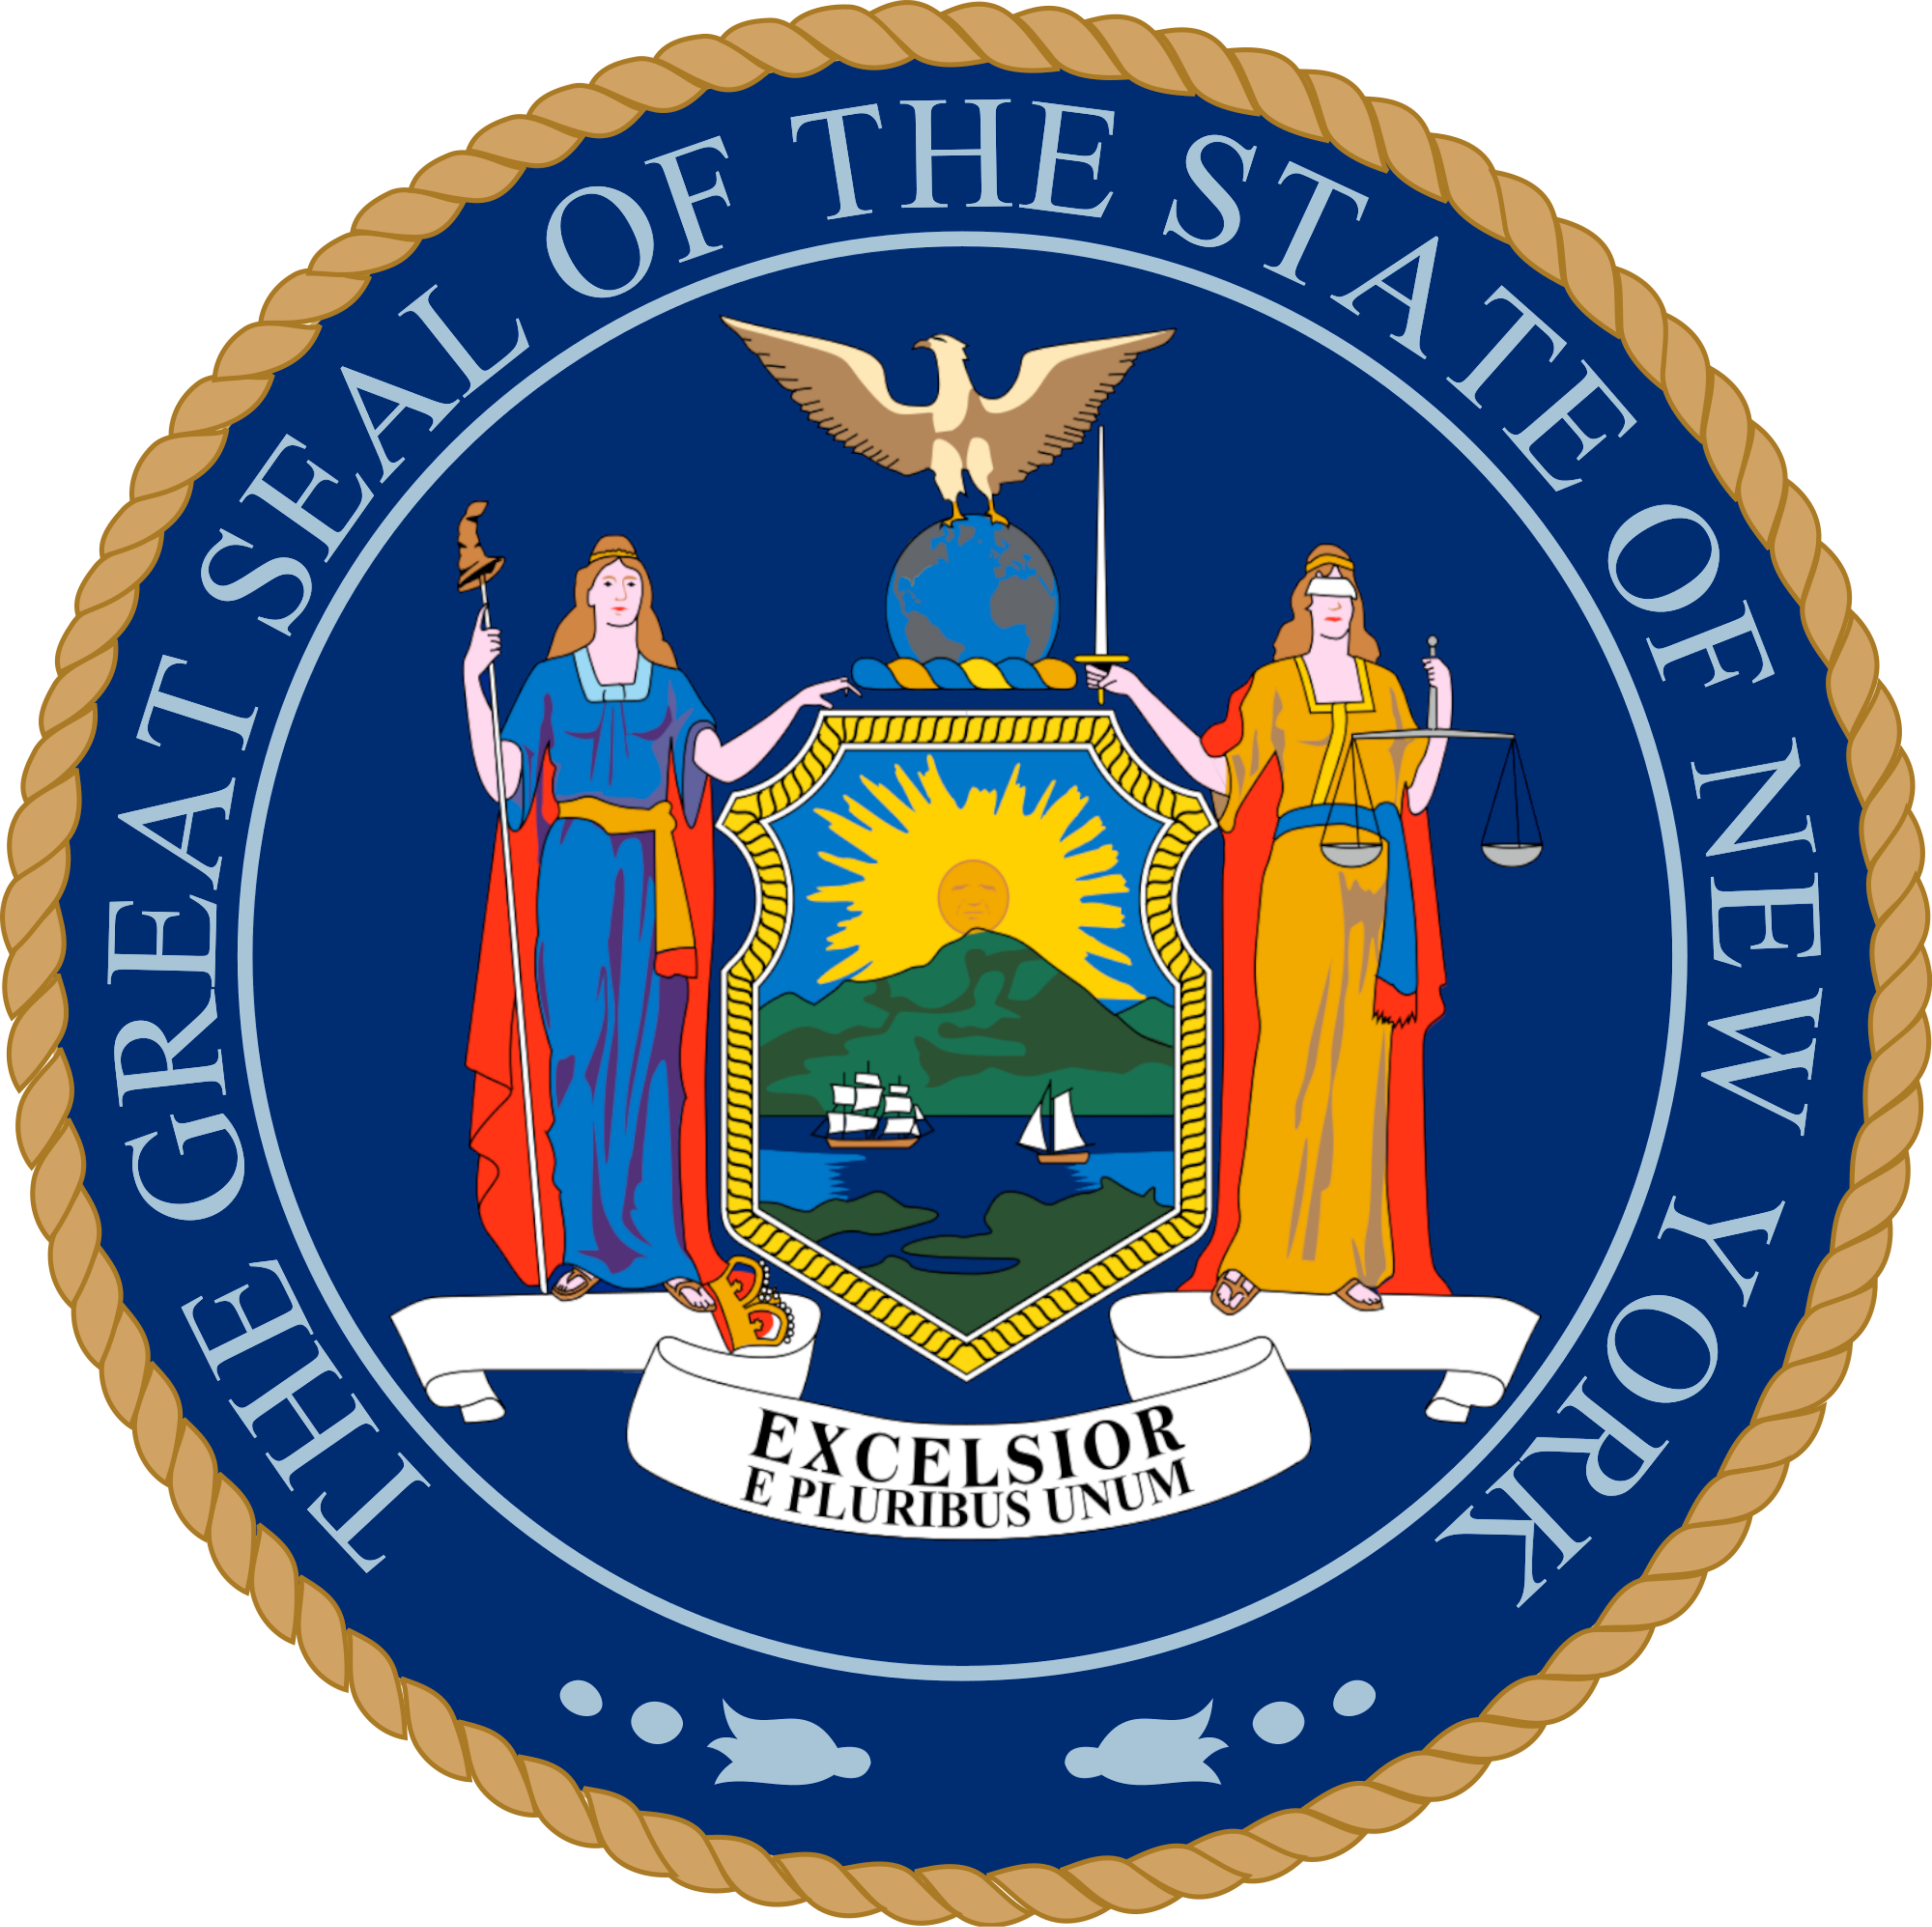
The Great Seal of the State of New York — Liberty and Justice flank the rising sun; Excelsior beneath · State of New York · Public domain · Wikimedia Commons
The city flag: a Dutch tricolor at heart
The New York City flag was approved on April 6, 1915 and first unveiled that June 24 — a vertical blue-white-orange tricolor derived from the Prince's Flag (Prinsenvlag) of the Dutch monarchy, charged with the city seal in blue. [18] The 1915 committee explained the arrangement: “the order of arrangement follows the practice found in the French, Belgian and other tri-colors, of placing the darkest bar next to the staff.” [18]
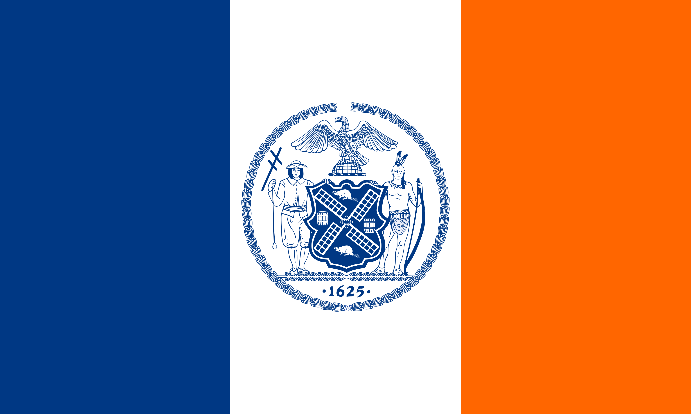 | 
The New York City flag — Prince's Flag colors, adopted 1915 · Zscout370 · CC BY-SA 3.0 · Wikimedia Commons | The Prince's Flag (Prinsenvlag) — the 17th-century Dutch royal standard whose orange the city kept · Miyamaki, Oren neu dag, Artem Karimov, Golradir · Public domain · Wikimedia Commons

The date on the seal: 1664 vs 1625
The exhibit's central charge in this section — that the seal's date was changed from 1664 to 1625 in a way that “manipulated the city's history” — is testable, and the record says: the change is real, and it happened twice. Two separate local laws did it, a fact most retellings (including Wikipedia's flag article) compress into one.
THE RECORD ON THE SEAL DATE — TWO LAWS, TWO YEARS
Until 1975: the flag and seal carried 1664, the year of the English capture (the 1915 redesign had itself changed the date from 1686, the Dongan Charter). [19]
Flag — Local Law 3 of 1975: Council President Paul O'Dwyer's bill (introduced June 16, 1974, timed to Amsterdam's 700th anniversary) changed the flag's date to 1625; it was passed and signed by Mayor Abraham Beame on January 8, 1975. [77][22]
Seal — Local Law 98 of 1977: a separate bill altered the seal itself; adopted December 13, 1977, approved by Beame on December 30, 1977. [77][22]
The aides' doubts: George Aridas, aide to First Deputy Mayor James A. Cavanagh, wrote: “In researching the validity of this proposal, I find no basis for 1625 as the founding date.” A second aide, Hank Walter, urged veto — 1624, the year of the first legal Dutch settlement, “was when the city actually became a legal Dutch entity.” [20]
Why 1625? O'Dwyer cast it as the year Manhattan was designated the seat of government; 1624 lost partly because its settlers were mostly Walloons — muddying the “honor the Dutch” theme. Borough historian Michael Miscione: “It is simply wrong… The first founding settlers of New York City landed here in 1624.” [20]
Today: the Administrative Code reads: “Date: … 1625, being the year of the establishment of New Amsterdam.” [21]

The exhibit's judgment — that this re-dating “manipulated the city's history to showcase Dutch involvement” — is an interpretation, and a defensible reading of the record: the laws were public acts with a plainly stated political purpose. What the record does not support is any suggestion of secrecy; both laws were enacted, published instruments. (The full provenance of this argument is documented in Part V.)
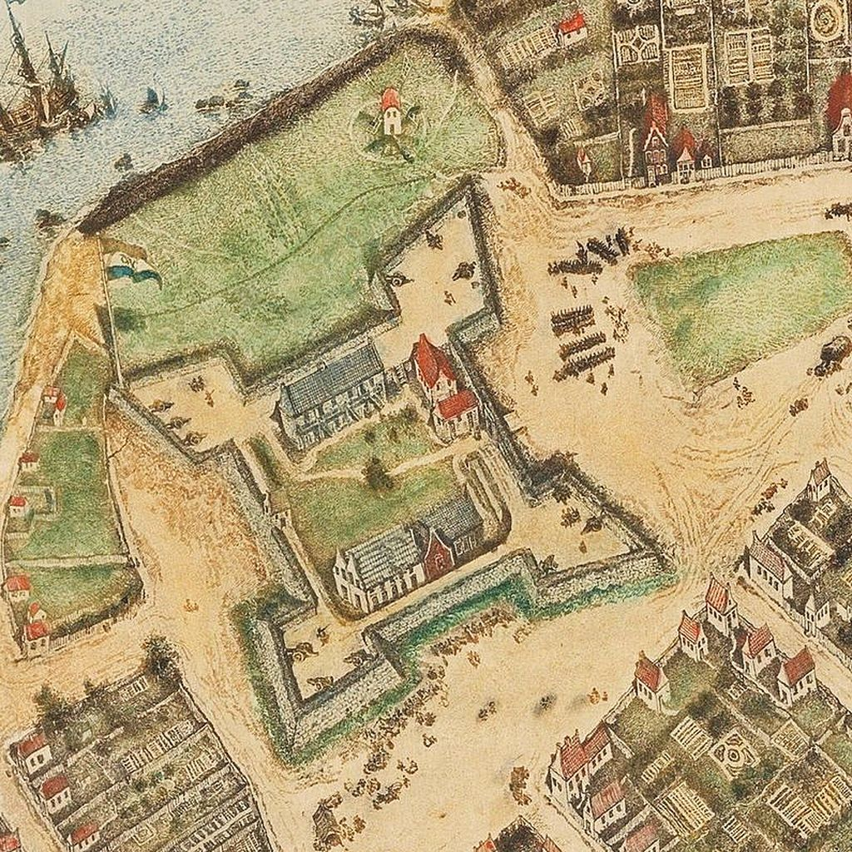
Fort Amsterdam, 1660 — the citadel at the tip of Manhattan whose construction era gave the city its new birthday · New Amsterdam created by surveyor Jacques Cortelyou in 1660. · Public domain · Wikimedia Commons
Sarah Rapelje — first child of New Netherland
Sarah Rapelje (June 9, 1625 – 1685), born at Fort Orange, is celebrated as the first European child born in New Netherland. Her parents, Joris Jansen Rapalje and Catalina Trico, were Walloon Calvinists who sailed on the Eendracht in 1624 among the first families. Sarah later received “a large tract of land in the Wallabout in Brooklyn”; her descendants include Humphrey Bogart, Tom Brokaw, Howard Dean, Clare Balding, and Mark O'Connor. [27] She married Hans Hansen Bergen in 1639 (eight children), remarried Teunis Gysbertse Bogaert after his 1653 death (seven more), and died in 1685 in Boswijck — today's Bushwick. The Rapelje chair survives in the Museum of the City of New York, and Rapelye Street in Brooklyn carries the family name. [27]
CORRECTION — the Minuit sentence
Original: “In 1626 Peter Minuit born in Wesel… is generally credited with orchestrating the purchase.”
Correction: Sentence garble — it fuses two facts. Minuit was born c. 1580–1585 in Wesel; he arrived in 1626 as the new Director-General and that year arranged the purchase. Both facts stand; the sentence did not.

The exhibit's USPS registry block — zip codes, post offices, and a jurisdictional argument about them — is preserved and examined in Part V. What belongs here is the geography: the Wallabout Bay of the Rapelje land grant is today the Brooklyn Navy Yard; the Navy Yard ZIP (11251) is real, as are the exhibit's post-office listings. The leap from postal geography to jurisdiction is the exhibit's own, and Part V tests it.
PART 3
THE 51ST STATE
“No more bullshit.”
— Norman Mailer's 1969 campaign slogan
IN THIS PART
- The platform: statehood, taxes, cars banned from Manhattan
- Sweet Sundays, jitneys, and the circum-Manhattan monorail
- June 17, 1969: the numbers
- Echoes — Staten Island 1993, Vallone 2003–08, Bloomberg 2008

PART III · CHAPTER 1
1969: Mailer, Breslin, and the 51st State
In 1969 the novelist Norman Mailer and columnist Jimmy Breslin ran for Mayor and City Council President on a platform of city statehood. The original exhibit preserves their platform in full. This edition adds what the original omits: the result, and the afterlife.
“New York City: the 51st State” was the platform of the Mailer–Breslin candidacy in the 1969 Democratic mayoral primary. The two entered the race formally on May 1, 1969 — seven weeks before the primary — with Mailer announcing under the slogan “No more bullshit.” [1][51] The core proposal: the five boroughs secede from New York State and become the 51st state, each neighborhood its own municipality, under the banner “Power to the Neighborhood.” [1][2] When a reporter asked what the new state would be called, Breslin said the city deserved to keep “New York” — upstate should be renamed “Buffalo.” [56]
 | 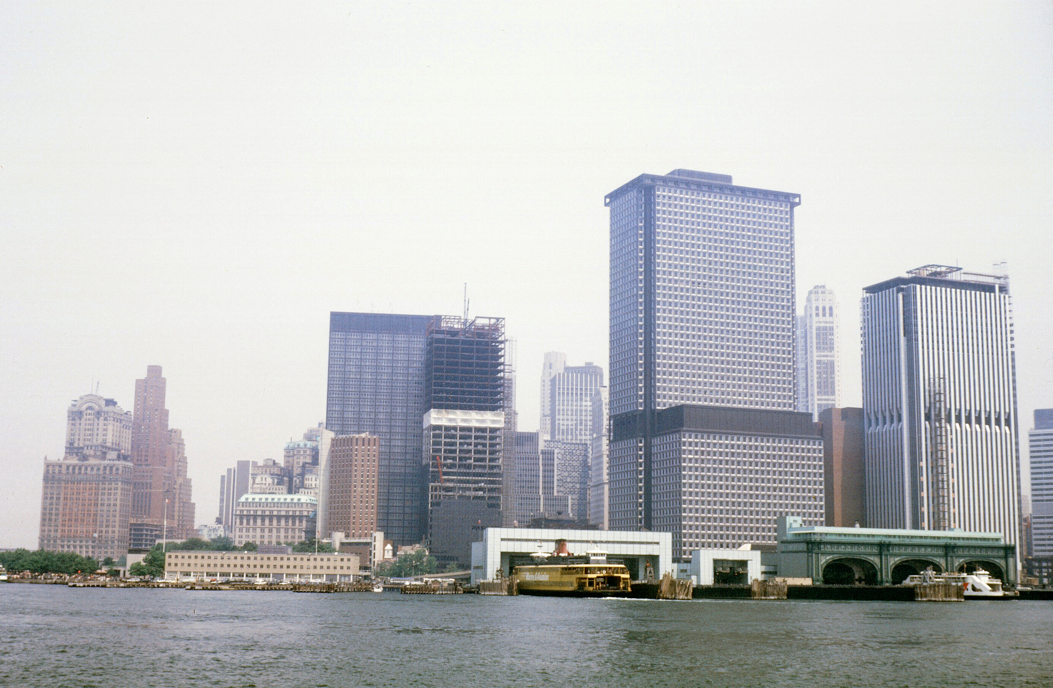
Norman Mailer, 1948 — novelist, filmmaker, candidate for Mayor, 1969 · Carl Van Vechten · Public domain · Wikimedia Commons | Lower Manhattan from the harbor, c. 1966–69 — the city Mailer proposed to make a state · Dada1960 · CC BY-SA 4.0 · Wikimedia Commons

The platform, plank by plank
The contents of this section are adapted from the Mailer–Breslin campaign literature, as preserved in the original exhibit and verified against the record:
- Statehood & referendum — the city split off as the 51th State; Mailer proposed that his first act after election be a citywide referendum on statehood. [1]
- Taxes — in 1969 city taxpayers paid state and federal governments $14 billion and got $3 billion back; the City-State would correct the imbalance and yield about $2 billion in additional revenue. (The Gotham Center's retrospective frames the campaign's own math differently — $2.5B to Albany, $1.385B returned in 1968 — both figures are campaign claims, quoted not audited.) [1][2]
- The casino — on Randall's Island, Roosevelt Island, or Coney Island, revenues to the City-State. [1]
- Cars — all private cars banned from Manhattan; a monorail around Manhattan's circumference serving parking lots outside the island; more cabs; free Midtown jitneys; publicly owned bicycles free to all. [1][51]
- Sweet Sundays — one Sunday a month with “absolutely all mechanized transport, including elevators, shut down” — clear the air, give the city a day to breathe. [1][52]
- Schools, housing, welfare, policing — each under neighborhood control: neighborhoods hiring their own teachers and police, managing rent-controlled housing, administering welfare with federal absorption of 90% of costs. [1]
“Giving authority to local residents united by history, interests, or ethnicity, would create some real power to the neighborhoods … power over their local boards of education, power to decide about the style and quality and number of the police force they want and are willing to pay for, power over the Department of Sanitation, power over their parks.”
— Norman Mailer, campaign literature, 1969
SWEET SUNDAYS
One Sunday each month, every form of mechanical transportation — including elevators — would be halted.
Mailer's idea: clear the air, and give the city “a carefree day” to gather and decompress. Sam Smith, editor of The Progressive Review, later wrote that Sweet Sundays “would allow human beings to rest and talk to each other and the air can purify itself. Mailer and Breslin understood that real politics is not just a matter of management but a collective expression of a community’s soul.”

June 17, 1969 — the numbers
Candidate (Dem. primary, for Mayor) | Votes | Share
Mario Procaccino — winner | 255,529* | ~33%
Robert F. Wagner Jr. | 224,464 | 29%
Herman Badillo | 217,165 | 28%
Norman Mailer | 41,288 | 5%
James H. Scheuer | 39,350 | 5%
Total votes cast | 777,796 | —

*Two source sets disagree by a few thousand votes: Wikipedia's table gives Procaccino 255,529 / Mailer 41,288; the Gotham Center gives 233,486 / 39,209. Both are quoted; neither is silently chosen. [1][2] What is not in dispute: Mailer finished fourth of five — beating Scheuer by 1,938 votes, outpolling him in Manhattan and on Staten Island — and Breslin lost too, taking 65,659 votes for Council President (second-to-last) as Hugh Carey won that race with 135,785. [1][2] Procaccino's win with under a third of the vote against four opponents inspired the use of runoffs in future primaries. [1]
The campaign's stunts are part of its legend: Mailer joked at the Village Gate about “compulsory free love in those neighborhoods that vote for it,” called himself a “left conservative,” and quipped of Mayor Lindsay that two more years would leave “only two things standing in New York — a photographer and the Honorable John, posing for pictures with his hair blowing in the wind.” Breslin, on why they'd entered: “we knew the one thing we could do better than the other politicians is to lie… we found out we were hopeless amateurs.” [52][2] A neighborhood stickball World Series was among the planned events. [2]
The afterlife of a losing platform
Contemporaries took it more seriously than the vote share suggests. TIME noted that Mailer had “revived the idea” of city statehood, that Lindsay appointed a commission to study it, and that Congresswoman Bella Abzug opened a drive for a November referendum petitioning Congress to admit the city. [57] Later historians have been kind: the Gotham Center's 2019 retrospective argues the campaign offered “a serious and important reconceptualization of what a city was and how it could function.” [2]
The idea has returned whenever the city's fiscal math turns bitter. In 1993, 65% of Staten Island voted to secede from the city itself — blocked in the State Assembly. [56] From 2003 to 2008, Council Member Peter Vallone Jr. introduced secession-referendum bills backed by 20 of 51 council members, on the claim that the state takes $3.5 billion more per year than it returns. [56][58] And in 2008, after testifying that the city sends Albany $11 billion more than it gets back, Mayor Michael Bloomberg laughed off actual secession on WABC — “You'd require a change to the state constitution, which we'd never get… that's not going to happen” — while agreeing “the message… is the right message.” [53][54]
CORRECTION — one myth worth killing
Campaign-trail legend says Mailer jousted on horseback during the race. No verified source in this edition's research confirms a joust; the documented stunts are the stickball World Series, the Village Gate provocations, and the “left conservative” interview. Marked [unverified] rather than repeated.

PART 4
THE INDIAN TERRITORY
“A state Congress refused — and a nation that refused to dissolve.”
— the Sequoyah and Cherokee stories, 1905–2020
IN THIS PART
- Article IV, Section 3: how states are made
- Vermont 1791 · Kentucky 1792 · Maine 1820 · West Virginia 1863
- Sequoyah 1905: the state Congress wouldn't take
- Cherokee Nation: dissolution, rebirth, and McGirt (2020)

PART IV · CHAPTER 1
How to Make a State
The original exhibit's Indian Territory section is its most legally literate: it correctly identifies Article IV, Section 3 as the constitutional gateway, and correctly cites Kentucky and West Virginia as precedent. It also contains the exhibit's most consequential error — the case name for the 2020 Supreme Court ruling.
Article IV, Section 3, Clause 1
“New States may be admitted by the Congress into this Union; but no new State shall be formed or erected within the Jurisdiction of any other State; nor any State be formed by the Junction of two or more States, or Parts of States, without the Consent of the Legislatures of the States concerned as well as of the Congress.”
— U.S. Constitution, Article IV, § 3, cl. 1
Congress alone admits states; carving a new one from an existing state needs the parent legislature's consent plus Congress's. [13] That consent requirement handed the original claimant states a veto over dismemberment — hence Kentucky's and West Virginia's need for Virginia's consent, and Maine's for Massachusetts's. [4] Every state enters “on an equal footing” with the original thirteen. [4]
The precedent set — with a New York irony
State | Year | Carved from | The consent
Vermont | 1791 | territory claimed by New York | NY consented March 6, 1790 — for $30,000
Kentucky | 1792 | Virginia (District of Kentucky) | Virginia legislature, Dec. 18, 1789
Maine | 1820 | Massachusetts (District of Maine) | Mass. enabling act, June 19, 1819
West Virginia | 1863 | Virginia (Restored Gov't) | rump legislature; voters 18,408–781

The irony the exhibit misses: the first new state admitted, Vermont, was carved from territory New York itself claimed — and New York's consent was bought for $30,000 and given March 6, 1790, a year before Vermont's admission. [11] West Virginia remains the most irregular: consent came from the Restored Government of Virginia — a rump legislature loyal to the Union — with loyalist voters approving statehood 18,408 to 781. Lincoln, doubting its legality, concluded: “the division of a state is dreaded as a precedent but a measure expedient by a war is no precedent for times of peace.” [23][5]
Sequoyah 1905: the state Congress refused
In August 1905 the citizens of the Five Civilized Tribes convened at the Hinton Theater in Muskogee, Creek Nation, and drafted a roughly 35,000-word constitution for the State of Sequoyah — approved by the territory's voters, Indian and white alike. Congress refused to consider it. [6] Instead the Oklahoma Enabling Act of June 16, 1906 empowered Indian Territory and Oklahoma Territory to be admitted as a single state; President Roosevelt's proclamation made Oklahoma the 46th state on November 16, 1907. [10]
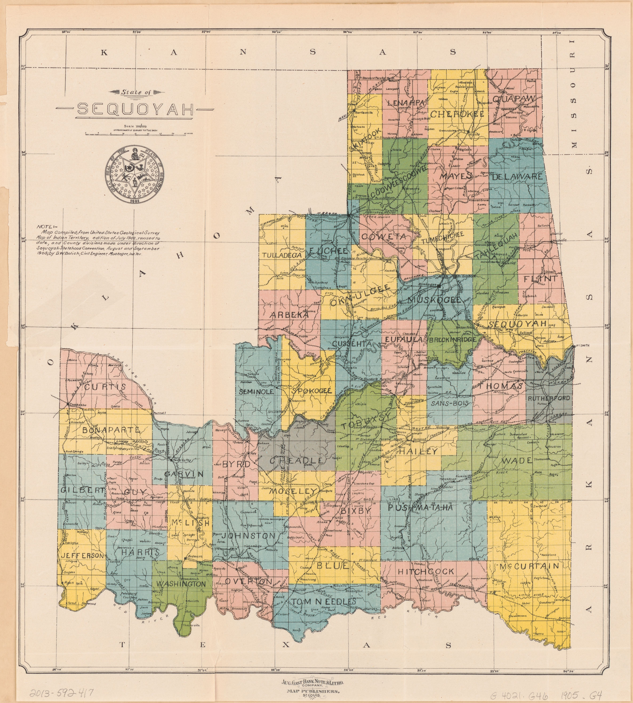
The State of Sequoyah — the 1905 proposed state Congress refused to admit · Geological Survey (U.S.) · Public domain · Wikimedia Commons
Cherokee Nation: dissolution and rebirth
The exhibit's Cherokee history is largely sound, and research confirms it clause by clause. The Cherokee Nation existed as an autonomous tribal government from 1794 to 1907; the Treaty of July 19, 1866 voided its Confederate alliance, required emancipation, and granted Cherokee Freedmen “all the rights of native Cherokees.” [3][17] The Curtis Act (1898) and the Five Tribes Act (1906) curtailed the tribal government ahead of Oklahoma statehood. [3]
After Principal Chief William Charles Rogers died in 1917, the federal government began appointing chiefs for terms so brief the era is remembered as “Chief for a Day” — the first, Andrew B. Cunningham, served November 8–25, 1919. [12] A 1938 convention chose J. B. Milam (FDR confirmed 1941); W. W. Keeler — president of Phillips Petroleum — was appointed 1949. [12] The Nation ratified a new constitution June 26, 1976, and in 1985 elected Wilma Mankiller the first female chief. [12][24]
CORRECTION — the 2020 Supreme Court case
Original: “On July 9, 2020, in Sharp v. Murphy, the United States Supreme Court advantageously ruled that the Muscogee (Creek) Nation and by extension the Cherokee Nation had never been disestablished.”
Correction: The controlling decision issued that day is McGirt v. Oklahoma, 591 U.S. 894 (2020) — 5–4, Justice Gorsuch writing — holding the Creek reservation was never disestablished. [7] Sharp v. Murphy was the companion case, held over after a believed deadlock, and decided the same day in a one-line per curiam following McGirt. [15] The exhibit's substantive point stands; the case name belongs to McGirt.
Also corrected throughout: the exhibit twice calls the American Civil War the “British-American Civil War (1861–1865).” It is the American Civil War — no British party; typographical corruption, fixed wherever quoted.

Modern echoes
Alaska and Hawaii (1959) were the last admissions. [4] The House passed a D.C. admission bill in 2020 and 2021 (216–208) but the Senate door stayed shut; Puerto Rico has held seven status referendums since 1967 — statehood winning the last four — all non-binding, because the power to grant statehood lies with Congress. [16][14] Sequoyah's heirs are still waiting at that door.
PART 5
THE EXHIBIT'S CLAIMS
“Documented. Cited. Not endorsed.”
— editorial policy of this edition
IN THIS PART
- The ZIP-code / admiralty jurisdiction theory
- The “United States is a corporation” theory
- The 1977 “re-establishment” theory
- The Development Corporation for Israel registry
- How to read an exhibit like this

PART V · CHAPTER 1
The Exhibit's Legal Claims — Documented, Not Endorsed
The final section of the original document is a claims file: ZIP codes as admiralty jurisdiction, the United States as a chartered commercial corporation, the city's 1977 legislation as a “re-establishment” of the Thirteen Colonies. These are presented verbatim, then documented for provenance and court treatment. Nothing here is legal advice, and nothing here is endorsed.
CLAIM 1
“Postal codes are used to invoke Admiralty jurisdiction, and the use of ANY ZIP Code devolves to the NEW YORK, NY and or MANHATTAN, NY jurisdiction. A ZIP Code address is used to create a “federal jurisdiction” or “market venue” or “revenue district” that override State boundaries…”
DOCUMENTED THEORY · UNIFORMLY REJECTED BY COURTS
Provenance. “ZIP” is the Postal Service's Zone Improvement Plan, introduced July 1, 1963 purely to speed mail sorting — a postal measure, not a jurisdictional one. [64][63] The jurisdictional reading is a tenet of the sovereign-citizen movement: avoiding ZIP codes is believed to decline a “contract” with the state. [66] The exhibit's exact phrasing — “federal jurisdiction… market venue… revenue district… admiralty concerns” — traces verbatim to a widely circulated tax-protester text documented by the Tax Protester FAQ. [65]
Judicial treatment. No reported U.S. decision accepts the theory. The allied fringed-flag/admiralty argument has been rejected expressly: Greenstreet — “To think that a fringed flag adorning the courtroom somehow limits this Court's jurisdiction is frivolous”; Vella — “without merit,” “totally frivolous.” [67][68] Canada's Meads v. Meads (2012 ABQB 571), the landmark catalog of “Organized Pseudolegal Commercial Arguments,” lists postal-code avoidance as a recognized scheme: use of a postal code is thought “to mean… accepting some kind of contract with the state.” [69]
A citation caution. Sovereign-citizen sources often cite Benner and Burkhart as ZIP-rejection authorities. The reported decisions contain no ZIP-code holding — Benner is a one-line affirmance; Burkhart's listed objections do not include ZIP codes. This edition does not cite them as ZIP authorities. [79][78]

CLAIM 2
“…into an international, commercial venue involving admiralty concerns of the “United States”, which is a commercial corporation chartered by the United States Organization or UNO.”
DOCUMENTED THEORY · STATUTE MISREAD
Provenance. The corporate reading rests on 28 U.S.C. § 3002(15) — a definitions provision of the Federal Debt Collection Procedures Act — whose text reads: “(15) ‘United States’ means— (A) a Federal corporation; (B) an agency, department, commission, board, or other entity of the United States; or (C) an instrumentality of the United States.” [70] The statute is real; the misreading is treating a chapter-scoped definition of “United States” for debt-collection purposes as a declaration that the sovereign is a private corporation. A second strand ties to the District of Columbia Organic Act of 1871, which incorporated the District's municipal government — as most U.S. cities are incorporated. [73] The “chartered by the UN/UNO” element traces to the same tax-protester text as Claim 1. [65]
Judicial treatment. United States v. Boyce (C.D. Cal. 2014) addressed § 3002(15) directly — the court found the contention “unavailing” because the subsection defines “United States” only for the debt-collection chapter. [72] In the 2017 Beane prosecution the government recorded the same argument as “foreclosed and terminated… no legal merit.” [71] No decision accepts the theory; the UN-charter element has no documented judicial or legislative source at all. [unverified]

CLAIM 3
“1977 – The Re-Establishment of the 13 Colonies d.b.a.: New Netherland / The City of New York”
EXHIBIT'S OWN THEORY · NO EXTERNAL SUPPORT FOUND
This heading is the original exhibit's own synthesis — this edition's research found no external support for it in any statute, council record, decision, or scholarly work surveyed. [unverified] What the record shows is narrower: the flag's date changed by Local Law 3 of 1975 (signed January 8, 1975) and the seal's by Local Law 98 of 1977 (approved December 30, 1977) — both public, published instruments.
The “d.b.a.” phrasing echoes a documented OPCA motif — Meads records litigants styling officials as “'name' doing business as 'NAME',” an “everything is a contract” signature. [69] The exhibit's specific historical claim — a covert restoration of New Netherland — appears original to it, and is preserved here verbatim as the exhibit's thesis. The Thirteen Colonies list that follows it in the original is accurate as far as it goes, and is reproduced in the online appendix.

CLAIM 4
“Development Corporation for Israel — DOS ID 104147, filed 1955-03-21, CEO Israel Maimon, 641 Lexington Ave, New York”
REGISTRY DATA · PARTIALLY VERIFIED
The exhibit reproduces a block of New York Department of State registry data for the Development Corporation for Israel (DCI) — the U.S. underwriter of Israel Bonds — “a broker-dealer and member of the Financial Industry Regulatory Authority (FINRA),” with the inaugural Independence Issue offered in 1951. [74] SEC EDGAR confirms a DEVELOPMENT CORPORATION FOR ISRAEL, CIK 0000028471, incorporated in New York; [75] FINRA BrokerCheck shows the active firm, CRD 11148 / SEC 8-4218, at P.O. Box 5263, New York, NY 10150. [76]
Two fields need flags: CEO — Israel Maimon led the organization 2016–2021, so the exhibit's data matches a past, not the current, chief executive (Dan Naveh holds the office now). [{ISRAELBONDS}] And the DOS ID / filing date could not be independently confirmed against the automated-access-blocked NYSDOS registry — plausible and consistent with the EDGAR record, but marked [unverified] pending a manual lookup.
The exhibit never states what this block is meant to prove — it is juxtaposed, not argued. A foreign-sovereign bond underwriter being a New York domestic corporation is unremarkable on its face; this edition reproduces the registry data as a faithful record and lets the reader weigh the juxtaposition.

How to read an exhibit like this
The exhibit's legal theories sit inside a movement with a documented history. Meads v. Meads remains the single best map of that world — its catalog of “everything is a contract” schemes explains both the ZIP-code theory (Claim 1) and the “d.b.a.” styling (Claim 3) as recognizably kin. [69] Courts have been uniform; scholars have been thorough; and the honest exhibit response is neither ridicule nor credulity, but citation. That is what this Part V is for.
EDITORIAL NOTE — WHY PART V EXISTS
An exhibit that quoted these claims without documentation would be advocacy. One that deleted them would be censorship of its own source. This edition chose a third path: quote exactly, document provenance, report court treatment, mark the unresolvable [unverified].
Readers who want the full research annex — verbatim evidence quotes for every citation, the complete source ledger, and the four research briefs behind this edition — will find them at reinventionnewyork.com.

NOTES & SOURCES
Every citation in this edition resolves to the URLs below, in the order cited.
[1] New York City: the 51st State - Wikipedia — https://en.wikipedia.org/wiki/New_York_City:_the_51st_State
[2] The 51st State: Mailer, Breslin, and the Politics of Imagination - Gotham Center — https://www.gothamcenter.org/blog/the-51st-state-norman-mailer-jimmy-breslin-and-the-politics-of-imagination
[3] Cherokee Nation (1794-1907) - Wikipedia — https://en.wikipedia.org/wiki/Cherokee_Nation_(1794%E2%80%931907%29
[4] Admission to the Union - Wikipedia — https://en.wikipedia.org/wiki/Admission_to_the_Union
[5] West Virginia - Wikipedia — https://en.wikipedia.org/wiki/West_Virginia
[6] Sequoyah Convention - Encyclopedia of Oklahoma History and Culture — https://www.okhistory.org/publications/enc/entry?entry=SE021
[7] McGirt v. Oklahoma - Wikipedia — https://en.wikipedia.org/wiki/McGirt_v._Oklahoma
[8] Kentucky - Wikipedia — https://en.wikipedia.org/wiki/Kentucky
[9] Maine - Wikipedia — https://en.wikipedia.org/wiki/Maine
[10] Oklahoma Enabling Act - Wikipedia — https://en.wikipedia.org/wiki/Oklahoma_Enabling_Act
[11] Vermont Republic - Wikipedia — https://en.wikipedia.org/wiki/Vermont_Republic
[12] Cherokee Nation - Wikipedia — https://en.wikipedia.org/wiki/Cherokee_Nation
[13] Article Four of the United States Constitution - Wikipedia — https://en.wikipedia.org/wiki/Article_Four_of_the_United_States_Constitution
[14] Puerto Rico statehood movement - Wikipedia — https://en.wikipedia.org/wiki/Puerto_Rico_statehood_movement
[15] Sharp v. Murphy - Wikipedia — https://en.wikipedia.org/wiki/Sharp_v._Murphy
[16] District of Columbia statehood movement - Wikipedia — https://en.wikipedia.org/wiki/District_of_Columbia_statehood
[17] Treaty with the Cherokee, 1866 - Oklahoma State University Library — https://treaties.okstate.edu/treaties/treaty-with-the-cherokee-1866-0942
[18] Flags of New York City (Wikipedia) — https://en.wikipedia.org/wiki/Flags_of_New_York_City
[19] Seal of New York City (Wikipedia) — https://en.wikipedia.org/wiki/Seal_of_New_York_City
[20] New York's Birth Date: Don't Go by City's Seal — NYT, Sam Roberts, 2008 — https://www.nytimes.com/2008/07/14/nyregion/14seal.html
[21] NYC DCAS Green Book: City Seal and Flag — https://www.nyc.gov/site/dcas/about/green-book-city-seal-and-flag.page
[22] Paul O'Dwyer and Changing New York History — Leo Hershkowitz — http://www.tolerancepark.org/sitebuildercontent/sitebuilderfiles/birthnovumbelgium1624andbirthnovumamsterodamum1625hershkowitzanddekoning.pdf
[23] Statehood for West Virginia: An Illegal Act? - WV Archives and History — https://archive.wvculture.org/History/journal_wvh/wvh30-1.html
[24] Wilma Mankiller - Wikipedia — https://en.wikipedia.org/wiki/Wilma_Mankiller
[25] New Amsterdam (Wikipedia) — https://en.wikipedia.org/wiki/New_Amsterdam
[26] Peter Minuit (Wikipedia) — https://en.wikipedia.org/wiki/Peter_Minuit
[27] Sarah Rapelje (Wikipedia) — https://en.wikipedia.org/wiki/Sarah_Rapelje
[28] Juan Rodriguez (trader) (Wikipedia) — https://en.wikipedia.org/wiki/Juan_Rodriguez_%28trader%29
[29] Peter Stuyvesant (Wikipedia) — https://en.wikipedia.org/wiki/Peter_Stuyvesant
[30] Treaty of Breda (Wikipedia) — https://en.wikipedia.org/wiki/Treaty_of_Breda
[31] Thomas Willett (Wikipedia) — https://en.wikipedia.org/wiki/Thomas_Willett
[32] Fort Nassau (Wikipedia) — https://en.wikipedia.org/wiki/Fort_Nassau
[33] Coney Island (Wikipedia) — https://en.wikipedia.org/wiki/Coney_Island
[34] Breukelen (Wikipedia) — https://en.wikipedia.org/wiki/Breukelen
[35] New Netherland (Wikipedia) — https://en.wikipedia.org/wiki/New_Netherland
[36] Fort Amsterdam (Wikipedia) — https://en.wikipedia.org/wiki/Fort_Amsterdam
[37] Governors Island (Wikipedia) — https://en.wikipedia.org/wiki/Governors_Island
[38] History of New York City (Wikipedia) — https://en.wikipedia.org/wiki/History_of_New_York_City
[39] Walloons (Wikipedia) — https://en.wikipedia.org/wiki/Walloons
[40] Kieft's War (Wikipedia) — https://en.wikipedia.org/wiki/Kieft%27s_War
[41] Treaty of Westminster 1674 (Wikipedia) — https://en.wikipedia.org/wiki/Treaty_of_Westminster_%281674%29
[42] Fort Orange (New Netherland) (Wikipedia) — https://en.wikipedia.org/wiki/Fort_Orange_%28New_Netherland%29
[43] Bowery (Wikipedia) — https://en.wikipedia.org/wiki/Bowery
[44] Canarsee (Wikipedia) — https://en.wikipedia.org/wiki/Canarsee
[45] Harlem (Wikipedia) — https://en.wikipedia.org/wiki/Harlem
[46] Greenwich, Connecticut — Greenwijck etymology (Wikipedia) — https://en.wikipedia.org/wiki/Greenwich,_Connecticut
[47] History of New York City prehistory-1664 (Wikipedia) — https://en.wikipedia.org/wiki/History_of_New_York_City_(prehistory%E2%80%931664)
[48] Conquest of New Netherland (Wikipedia) — https://en.wikipedia.org/wiki/Conquest_of_New_Netherland
[49] Flushing, Queens — Vlissingen (Wikipedia) — https://en.wikipedia.org/wiki/Flushing,_Queens
[50] History of Manhattan (Wikipedia) — https://en.wikipedia.org/wiki/History_of_Manhattan
[51] When Norman Mailer Wanted NYC To Be the 51st State - Untapped New York — https://untappedcities.com/2014/03/27/daily-what-when-norman-mailer-wanted-nyc-to-be-the-51st-state
[52] When Norman Mailer ran for mayor in 1969 - Ephemeral New York — https://ephemeralnewyork.wordpress.com/2011/11/09/when-norman-mailer-ran-for-mayor-in-1969
[53] Bloomberg Skeptical About Secession - New York Observer — https://observer.com/2008/02/bloomberg-skeptical-about-secession-but-does-see-nyc-as-the-economic-engine
[54] It's That Time Again - Time to Talk NYC Secession - Gothamist — https://gothamist.com/news/its-that-time-again-time-to-talk-nyc-secession
[55] Mario Procaccino - Wikipedia — https://en.wikipedia.org/wiki/Mario_Procaccino
[56] Partition and secession in New York - Wikipedia — https://en.wikipedia.org/wiki/Partition_and_secession_in_New_York
[57] The Nation: Should New York City Be the 51st State? - TIME 1969 — https://time.com/archive/6839013/the-nation-should-new-york-city-be-the-51st-state
[58] Notion of a 51st State Comes Around Again - NYT 2003 — https://www.nytimes.com/2003/05/02/nyregion/notion-of-a-51st-state-comes-around-again.html
[59] Peter Stuyvesant — Spartacus Educational — https://spartacus-educational.com/USAstuyvesant.htm
[60] Remembering Pavonia — The Public History Project — https://www.publichistoryproject.org/remembering-pavonia
[61] Wyandanch and the Dispossession of Indian Land — Long Island History Journal — https://lihj.cc.stonybrook.edu/2022/articles/wyandanch-and-the-dispossession-of-indian-land-on-long-island-new-yorkgrand-sachem-puppet-or-culture-broker
[62] Greenwich Village — Groenwijck (Wikipedia) — https://en.wikipedia.org/wiki/Greenwich_Village
[63] Smithsonian National Postal Museum - From Zone Codes to ZIP Codes — https://postalmuseum.si.edu/the-20th-century-from-zone-codes-to-zip-codes
[64] Library of Congress - ZIP Code Introduced July 1 1963 — https://guides.loc.gov/this-month-in-business-history/july/zip-code-introduced
[65] Evans, Tax Protester FAQ - zip code / admiralty arguments — https://evans-legal.com/dan/tpfaq.html
[66] Wikipedia - Sovereign citizen movement — https://en.wikipedia.org/wiki/Sovereign_citizen_movement
[67] United States v. Greenstreet, 912 F. Supp. 224 (N.D. Tex. 1996) — https://hallapproved.com/tx/cases/federal/district/1996/1986395
[68] Vella v. McCammon, 671 F. Supp. 1128 (S.D. Tex. 1987) + citing cases — https://syfert.com/federal/district/cases/671-f-supp-1128/vella-v-mccammon
[69] Meads v. Meads, 2012 ABQB 571 (CanLII) - full decision PDF — https://ia902301.us.archive.org/26/items/sovereignty_20211014/Sovereignty/2012%20ABQB%20571%20%28CanLII%29%20_%20Meads%20v.%20Meads%20_%20CanLII.pdf
[70] 28 U.S.C. § 3002 - Definitions (LII/Cornell) — https://www.law.cornell.edu/uscode/text/28/3002
[71] United States v. Beane & Tucci-Jarraf, 3:17-cr-00082 (E.D. Tenn. 2017) - Gov't response re 28 U.S.C. 3002(15) — https://storage.courtlistener.com/recap/gov.uscourts.tned.82728.46.0.pdf
[72] United States v. Boyce, 38 F. Supp. 3d 1135 (C.D. Cal. 2014) — https://www.ecases.us/case/cacd/c5978916/united-states-v-boyce
[73] Wikipedia - District of Columbia Organic Act of 1871 — https://en.wikipedia.org/wiki/District_of_Columbia_Organic_Act_of_1871
[74] Wikipedia - Israel Bonds / Development Corporation for Israel — https://en.wikipedia.org/wiki/Israel_Bonds
[75] SEC EDGAR - Development Corporation for Israel (CIK 0000028471) — https://www.sec.gov/cgi-bin/browse-edgar?company=development+corporation&type=&dateb=&owner=include&count=100&action=getcompany
[76] FINRA BrokerCheck - Development Corporation for Israel (CRD 11148) — https://api.brokercheck.finra.org/search/firm?query=Development%20Corporation%20for%20Israel&includePrevious=false&hl=true&nrows=12&start=0&r=25&wt=json
[77] Flags of the World - New York City seal/flag dates 1975 and 1977 — https://www.crwflags.com/FotW/flags/us-nyc.html
[78] United States v. Burkhart, 501 F.2d 993 (6th Cir. 1974) - no ZIP-code holding — https://law.justia.com/cases/federal/appellate-courts/F2/501/993/254910
[79] Benner v. Commissioner, 618 F.2d 115 (9th Cir. 1980) - no ZIP-code holding — https://openjurist.org/618/f2d/115/benner-v-commissioner-of-internal

