THE REINVENTION OF THE CITY OF NEW YORK
FICTIVE DOCUMENTS ARCHIVE — ENHANCED EDITION

The City's Lines — Census Geography, Wards & Zones, Explained
The NYC Reference Guides
The guide expanded into a working reference: how wards died in 1938, how tracts were born, what the 1898 consolidation actually changed, what redlining maps really were — and what a ZIP code is and is not.
Word edition — the complete original document verbatim, followed by the editors' research dossier.
EDITOR'S INTRODUCTION
The original document: An NYPL research guide to finding the city's historical internal boundaries — wards, election districts, census tracts, redlining maps, and service zones.
This enhanced edition reproduces the source document verbatim (its own formatting and images intact), then appends the editors' research dossier with the verified history behind the document's claims. The PDF edition of this research is available on the same page.
THE ORIGINAL DOCUMENT — VERBATIM
Source file: Boundaries, Districts, and Zones in New York City - Census Boundaries.docx
Boundaries, Districts, and Zones in New York City: Census Boundaries
Census Boundaries - Boundaries, Districts, and Zones in New York City - Research Guides at New York Public Library Research Centers
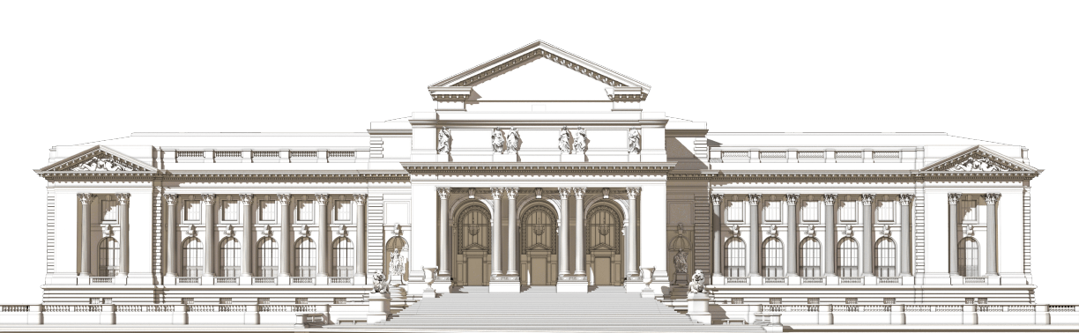
© The New York Public Library, 2026

The New York Public Library is a 501(c)(3) | EIN 13-1887440
This guide covers how to find cartographic materials related to the internal boundaries, districts, and zones of New York City.
- About
- Using Our Catalogs
- Census Boundaries
- Political Districts
- Buildings
- Neighborhood Services
- Emergency Services
- Historic Districts
- Redlining in NYC
- Environmental and Health Hazard Zones
Census Boundaries
Many types of research topics - such as genealogy, demographic studies, city planning, policy analysis, and urban planning - will require you to decipher or locate historical census boundaries that are referred to on census records. These boundaries include wards, assembly districts, election districts, or enumeration districts.
When using maps to get a better understanding of these referred boundaries on census records, some questions you can answer include:
- Where was this person living, in the context of New York City and their neighborhood?
- How was the city separated into various districts, and why? Does it change over time?
- What does the census data tell us about a specific neighborhood?
Before we can find maps that answer these types of questions, please see below for a brief explanation of the census numbering system(s).
Quick Links to Each Section on Page:
Defining ED, AD/ED, and Wards in the Context of the Census | Wards | Election Districts | Enumeration Districts | Assembly Districts
Defining ED, AD/ED, and Wards in the Context of the Census
ED in the 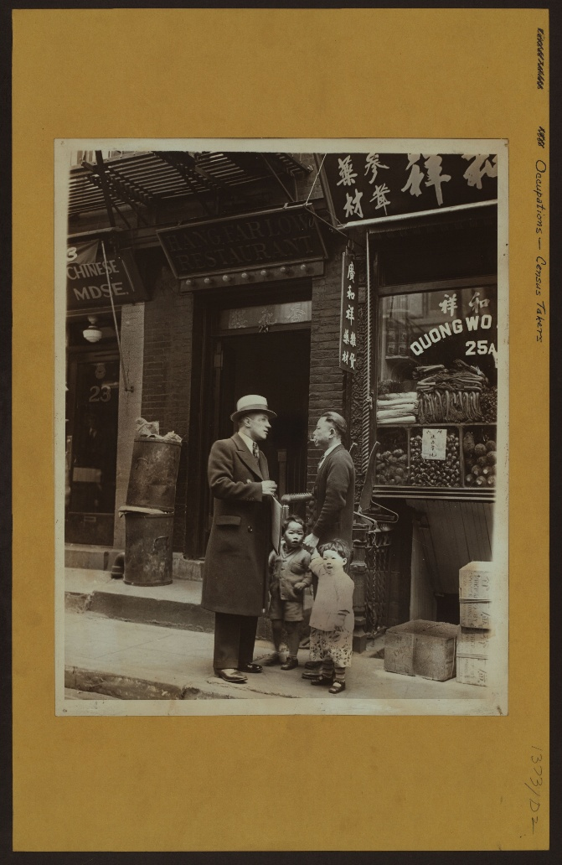
Federal Census:
You will be interested in an ED number, which is also also known as an Enumeration District. According to the National Archives, an enumeration district "was an area that an enumerator (census taker) could completely cover within two weeks in cities and within four weeks in rural areas."
On these census records, the ward that was covered is also denoted.
AD & ED in the NYS Census:
The New York State census utilized an AD/ED pair. In these cases:
- AD = Assembly District
  - Assembly Districts are further subdivided into Election Districts.
- ED = Election District
  - Not to be confused with the federal census' ED (Enumeration District).
These AD/ED pairs are the equivalent of the federal census' enumeration districts.
These pairs were used for:
- 1890 Police Census
- 1892 New York State Census (the AD number in this AD/ED pair refers to Ward)
- 1905 New York State Censuses
- 1915 New York State Censuses
- 1925 State Censuses
Please see below for ways to find enumeration district maps, assembly district maps, ward maps, and election district maps.
And, if you are interested in seeing how data collected from the census is incorporated into maps today, check out the following United States Census Bureau pages:
- Interactive Maps
- Tables & Maps
- Reference Maps
Lastly, if you are interested in conducting census-related research, we do recommend contacting the Irma and Paul Milstein Division of United States History, Local History and Genealogy at history@nypl.org for any questions you might have.
Source: Stephen Morses' Obtaining AD/ED for the 1890-1925 New York State Census in One Step: Frequently Asked Questions.
Image Source: Occupations - Census takers. 1930. NYPL Digital Collections Image ID 732277F
Wards
- Finding Maps
- Selection of Maps at NYPL
- Additional Resources and Databases
When using the Online Research Catalog:
- In the Advanced Search function, checkmark "Cartographic" under Format.
- We recommend the following keyword searches:
  - Wards [borough name]
  - Wards New York City
In some insurance atlases, the index plate and/or plates will indicate the locations of ward and ward boundaries. For example, when looking at Atlas of the borough of Brooklyn, City of New York : the first twenty eight wards complete in four volumes from 1903-1909:
- In the key of the Index Plate that the ward numbers are indicated in each plate by triangles and red lines for each ward's boundaries.
- Using Plate 1 as an example, you can see (based on the plate's title) that Wards 1, 2, & 4 are represented on this plate. In turn, you can see the triangles and red lines that depict the ward numbers and boundaries on this plate.
To learn more on how to search for these types of insurances atlases, please go to the Insurance Atlases: Blocks, Lots, and Property Boundaries section of Buildings page.
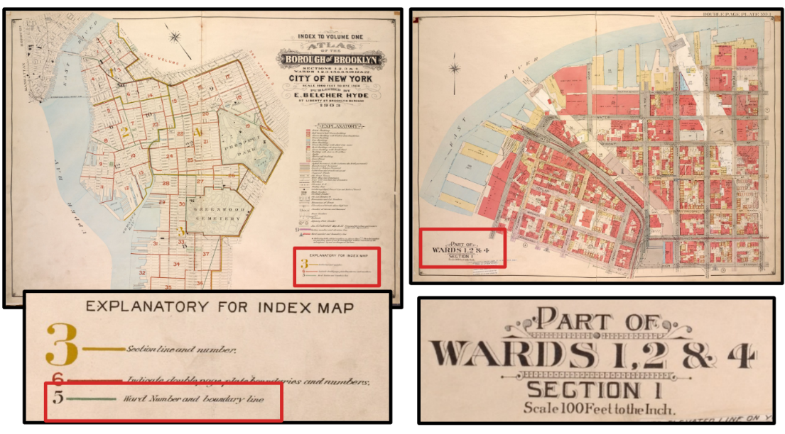
Image Source: Atlas of the borough of Brooklyn, City of New York : the first twenty eight wards complete in four volumes.1903-1909. NYPL Digital Collections Image ID 1695478 and 1695479
Election Districts
- Finding Maps
- Selection of Maps at NYPL
- Additional Resources and Databases
When using the Online Research Catalog:
- In the Advanced Search function, checkmark "Cartographic" under Format.
- We recommend the following keyword searches:
  - Election District [borough name]
    - Example: Election District Brooklyn
  - Election District New York City
  - Subject: New York (State) Legislature Election districts Maps
For maps of current election districts in New York City, please refer to the following resources:
- Maps on the Maps & Geography page of NYC's Planning Website:
  - Can be used to determine which district number is relevant to your region of interest, in relation to State Assembly, City Council, and State Senate.
- "Current NYC District Maps" on the Board of Elections in the City of New York.
  - Maps are organized by borough and then by election type/district number.
  - Please note that "New York City" is referring to districts in Manhattan.
  - Said maps also include locations of polls.
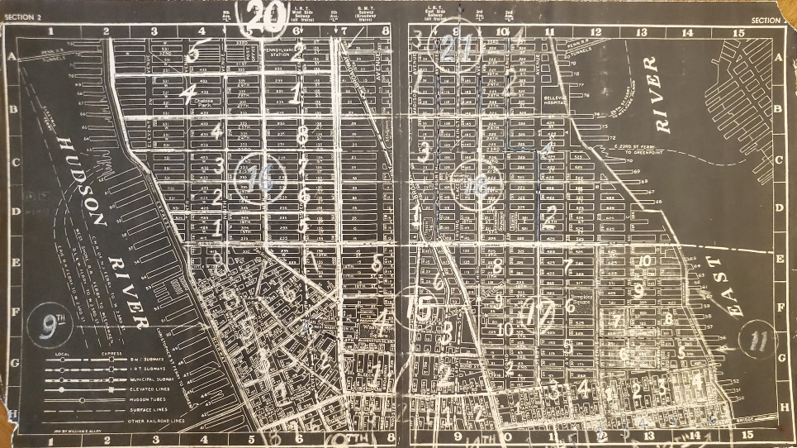
Image Source: Map from New York City voting places, 1855 / Gertrude A. Barber. [1855?] Map Div.+ (New York City. 1855) (New York City voting places, 1855)
Enumeration Districts
- Finding Maps
- Selection of Maps at NYPL
- Additional Resources and Databases
When using the Online Research Catalog:
- In the Advanced Search function, checkmark "Cartographic" under Format.
- We recommend the following keyword searches:
- Subject: Census districts New York (State) New York Maps
- Keyword Search: Enumeration District [borough name]
  - Example: Enumeration District Staten Island
- Keyword Search: Enumeration District New York City
Additional resources that have digitized enumeration district maps can be found at the National Archives' collection Enumeration District and Related Maps, 1880–1990:
- To see the records, click "Search Within Set"
- You can type in the region of interest in the search bar.
- On the results page, using the filter panel on the left, you can choose:
  - to see all the records, including those that have not been digitized.
  - only include the records that have been digitized.
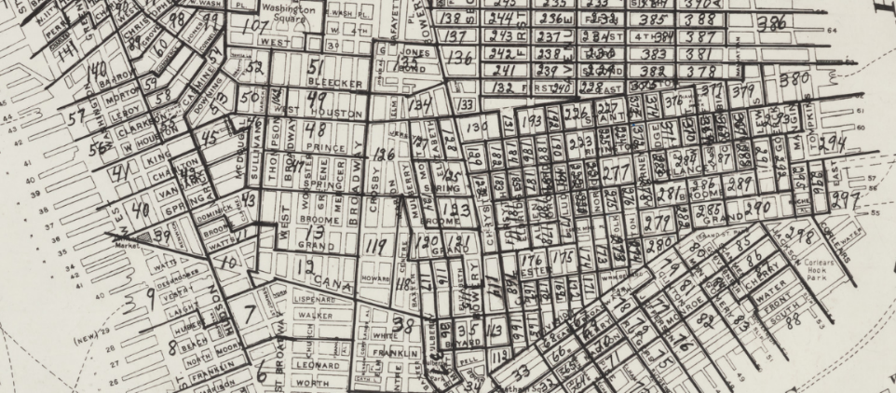
Image Source: Excerpt from [Map of 1900 census enumeration districts for Manhattan and the Bronx / prepared by Barbara Hillman]. NYPL Digital Collections Image ID 56738463
Assembly Districts
- Finding Maps
- Selection of Maps at NYPL
- Additional Resources and Databases
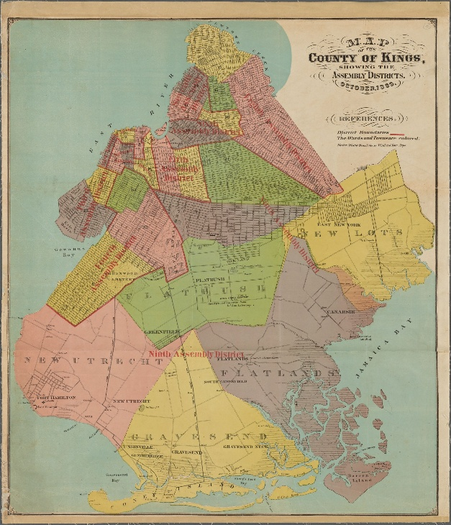
When using the Online Research Catalog:
- In the Advanced Search function, checkmark "Cartographic" under Format.
- We recommend the following searches:
  - Keyword: Assembly District [borough name]
    - Example: Assembly District Manhattan
  - Keyword: Assembly District New York City
  - Subject: New York (State) Legislature Assembly Election districts Maps
  - Subject: New York (State) Legislature Assembly Maps
For maps of current assembly districts in New York City, please refer to the following resources:
- "State Assembly District Maps by Borough" on the Maps & Geography page of NYC's Planning Website:
  - Can be used to determine which district number is relevant to your region of interest.
- "Current NYC District Maps" on the Board of Elections in the City of New York:
  - Maps are organized by borough and then by election type/district number.
  - Please note that "New York City" is referring to districts in Manhattan.
  - Said maps also include locations of polls.
Image Source: Map of the county of Kings, showing the Assembly districts, October 1869. [1869]. NYPL Digital Collections Image ID 4056204.

History
Brooklyn's Forgotten Electoral Districts: The Lost History of the Ward System
There are invisible, forgotten lines dividing Brooklyn in the form of the borough’s long unused ward system, an early version of today’s assembly and electoral districts.

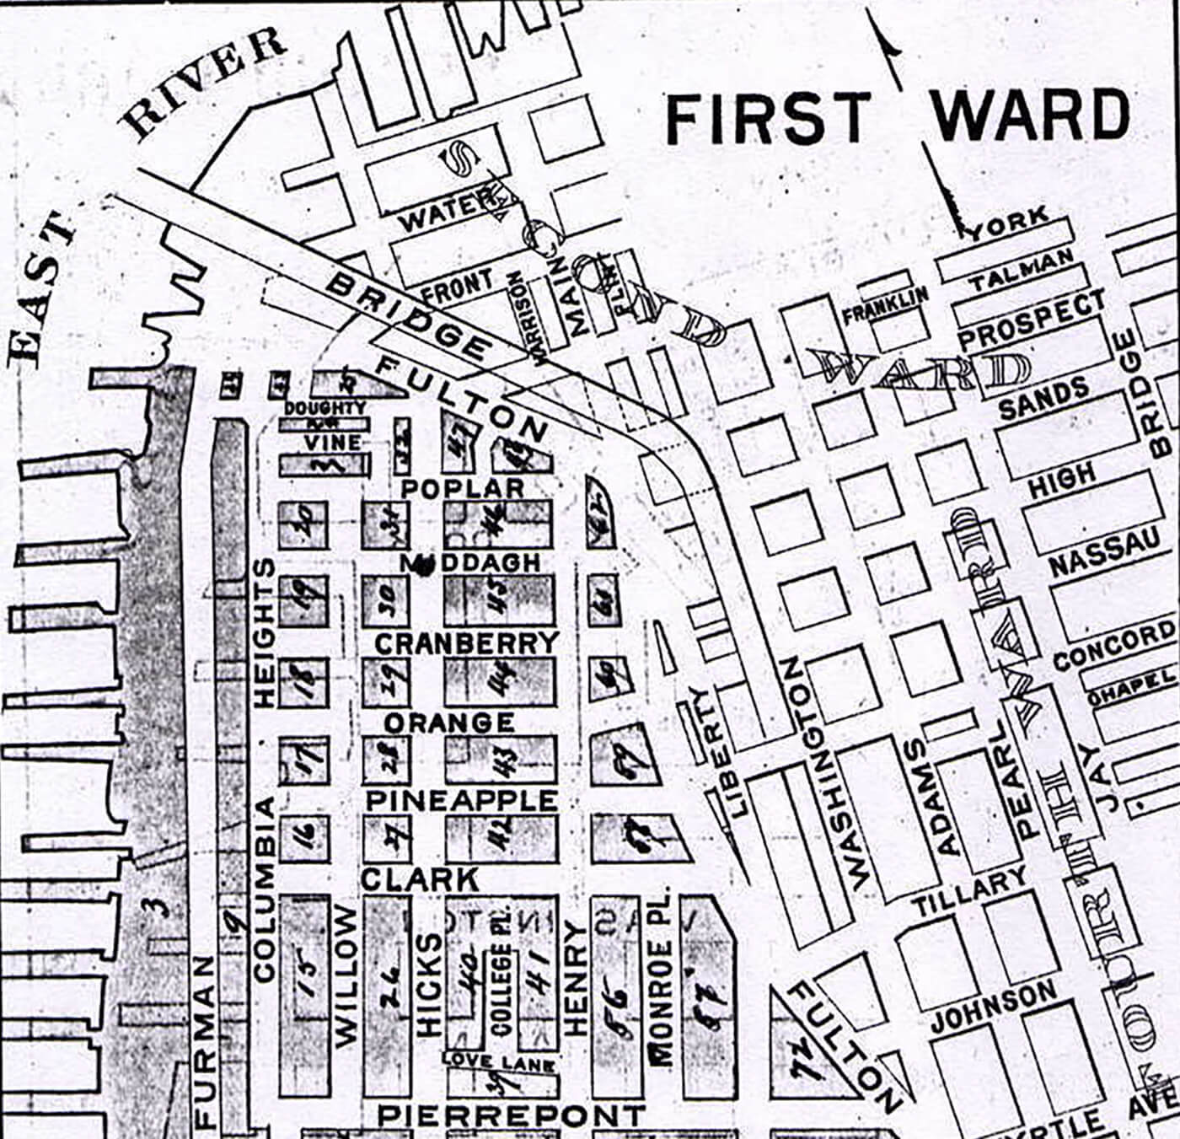
An 1893 map of Brooklyn Heights, Brooklyn’s first ward. Map via Brooklyn Genealogy
by Hannah Frishberg
05/17/20160Share
There are invisible, forgotten lines criss-crossing Brooklyn, long-lost borders dividing the borough into a series of numbered neighborhoods: Brooklyn’s wards.
Wards are the historic equivalent of today’s electoral districts: boundaries used in elections to designate voters to certain areas.
Some U.S. cities have maintained at least a portion of their ward designations — like New Orleans with its Katrina-decimated Ninth Ward, or Houston and its six historic wards — but Brooklyn today has only the barest reminders of its ward-divided past. One of the last hints of this history is the now-defunct 3rd Ward art space that once operated in East Williamsburg.
Brooklyn in Your Inbox
Stay up to date with more great news and articles like this one.

Sign Up

Yet, wards once played an outsized role in Brooklyn’s politics, representing voting districts and changing their borders and quantity to match Brooklyn as it grew.
In 1839, Brooklyn had nine wards. By 1898, that number had boomed with the city’s population to 32.
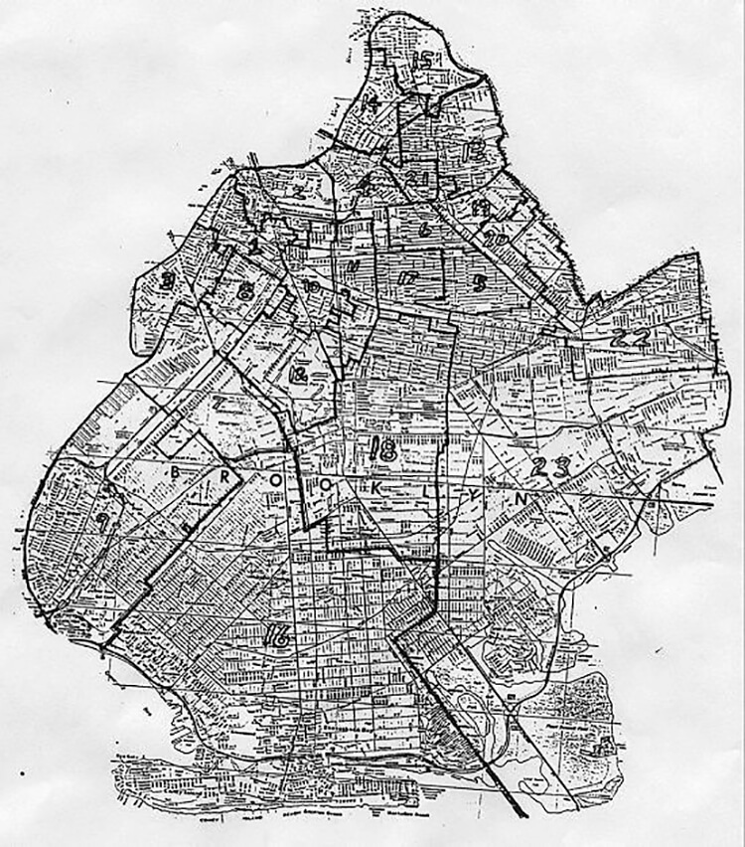A ward map of Brooklyn in 1915. Map via Brooklyn Genealogy
In 1915, Bed Stuy composed the 23rd and part of the 7th and 9th wards, Greenpoint was spread out over wards 8, 14, 15 and 17, and Brooklyn Heights was contained in wards 1 and 3, maps show.
The wards were very confusing, not seeming to follow any logical gridded boundary or numbering system, subdividing as Brooklyn’s population grew.
Even the papers seemed to have a hard time keeping up: “Gravesend Is in Now,” reads a Brooklyn Daily Eagle headline from 1894, “New Utrecht Will Follow in July. Flatlands Must Wait Until January 1, 1896.”
Counterintuitively, Gravesend was made the 31st ward before New Utrecht was made the 30th.
The Daily Eagle article goes on to explain the reason for the staggering of ward initiations was because of complications with the constitutional debt limit, a constraint concept that still exists today and limits the amount of debt a local government is allowed to incur.
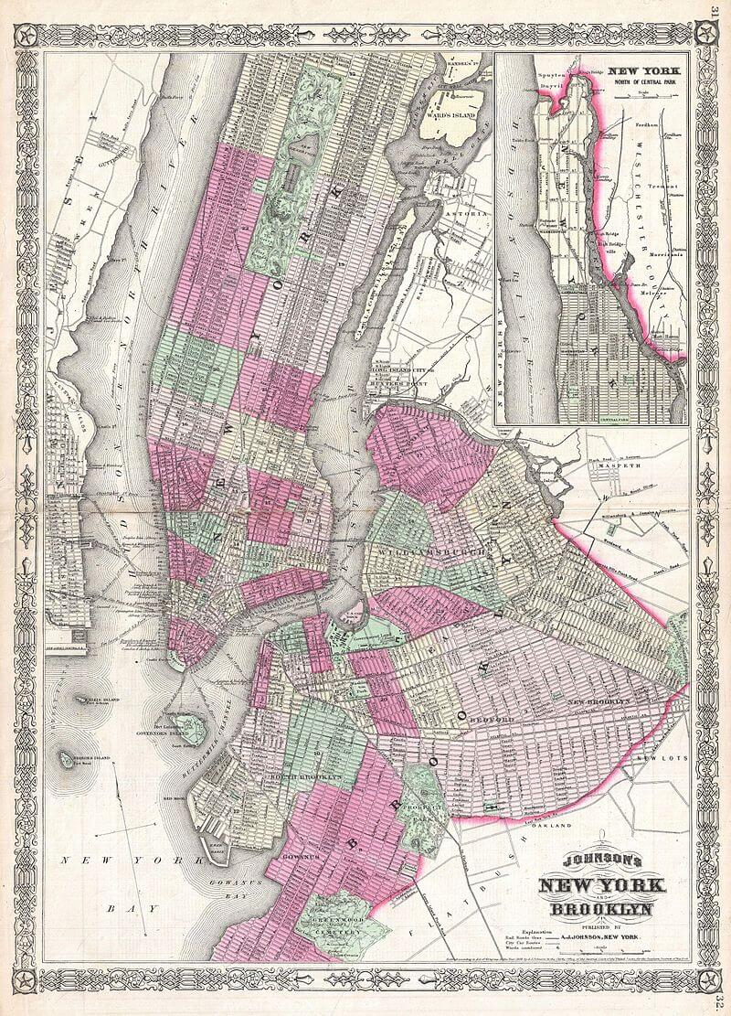An 1866 map showing the ward borders in both Brooklyn and Manhattan. Map via Wikipedia
Brooklyn stopped using wards in the early 20th century, and the system was formally abolished in 1938 according to Brooklyn Genealogy.
It took time for the term to leave the popular vocabulary, however. After the ward system was abandoned, electoral districts and assembly districts took its place.
Today, Brooklyn has 21 assembly districts.
Related Stories
5 of Brooklyn’s Worst Disasters, From the Subway to the Sky
A Sandhog Recalls Being Shot Out of a Brooklyn Heights Subway Tunnel
Demolished, Abandoned or Repurposed: Remembering Brooklyn’s Lost Subway Stations
Email tips@brownstoner.com with further comments, questions or tips. Follow Brownstoner on Twitter and Instagram, and like us on Facebook.

THE RESEARCH DOSSIER
NYC Boundaries, Districts & Zones — Census Geography and the ZIP/Jurisdiction Theme
Research note for the Fictiv educational exhibit · Compiled 2026-10-13 Raw doc: raw/'Boundaries, Districts, and Zones in New York City - Census Boundaries.md' (NYPL Research Guide capture + appended Brownstoner article on Brooklyn's wards) Related raw doc: raw/'NYC - NYS - UN or UNITED CHEROKEE NATIONS.md' (ties into the UN headquarters-district section, §2.7 below) Site lane: extends reinventionnewyork.com's existing ZIP-code legal-theories exhibit. Every number below was verified against a cited source during this session unless tagged [verify] (standard history, worth a quick check before print).

1. CONTENT MAP — what the raw doc covers
The capture has two parts:
Part A — NYPL Research Guide: "Census Boundaries" (a how-to-find-maps guide, not a history):
• Why census boundaries matter: genealogy, demographic studies, city planning, policy analysis all require deciphering ward / assembly-district / election-district / enumeration-district labels on census records.
• Defining ED, AD/ED, and wards: federal-census ED = Enumeration District (NARA definition quoted: "an area that an enumerator could completely cover within two weeks in cities and within four weeks in rural areas"). NYS-census AD/ED pair = Assembly District + Election District, not to be confused with the federal ED; pairs used for the 1890 Police Census and the 1892, 1905, 1915, 1925 NYS censuses. (On the 1892 census, the AD number refers to the ward.)
• Four finding-aids sections (Wards · Election Districts · Enumeration Districts · Assembly Districts), each with: catalog keyword searches for NYPL's Online Research Catalog ("Cartographic" format filter), a selection of NYPL maps/atlases (e.g., the 1903–09 Atlas of the borough of Brooklyn … first twenty eight wards, whose index plates mark ward boundaries in red lines and triangles), current-district map sources (NYC Planning "Maps & Geography"; Board of Elections "Current NYC District Maps" — note: on BOE maps "New York City" means Manhattan districts only), and pointers to NARA's Enumeration District and Related Maps, 1880–1990 digitized collection.
• Credit trail: the guide leans on Stephen Morse's One-Step AD/ED FAQ; page images are NYPL Digital Collections items (1930 census-taker photo, ID 732277F; Brooklyn atlas plates 1695478/1695479; Hillman's 1900 Manhattan/Bronx ED map, ID 56738463; an 1869 Kings County assembly-district map, ID 4056204).
Part B — appended Brownstoner article, Hannah Frishberg, "Brooklyn's Forgotten Electoral Districts: The Lost History of the Ward System" (5/17/2016):
• Brooklyn's wards as "invisible, forgotten lines"; historic equivalents of today's electoral districts.
• Growth arc: 9 wards in 1839 → 32 wards by 1898; 1915 examples (Bed-Stuy = 23rd + parts of 7th and 9th; Greenpoint spread over 8, 14, 15, 17; Brooklyn Heights in 1 and 3).
• 1894 Brooklyn Daily Eagle coverage: Gravesend (31st ward) annexed before New Utrecht (30th); Flatlands waiting until 1896 — the staggering driven by the constitutional debt limit.
• "Brooklyn stopped using wards in the early 20th century, and the system was formally abolished in 1938"; replaced by electoral + assembly districts; "Today, Brooklyn has 21 assembly districts."
What the doc does NOT cover (and this note supplies): census tracts, 1898 consolidation mechanics, HOLC redlining maps, ZIP codes, special districts (BIDs, historic districts), and the UN headquarters district. The guide is a cartographic finding aid; it makes no legal claims about boundaries.

2. THE RECORD — verified deep history with citations
2.1 Wards (1683–1938)
• 1683–1791: NYC's first six wards created December 8, 1683 (five in the lower-Manhattan built-up city plus the "Out Ward" covering the rest); the Dongan Charter (1686) confirmed them, each electing an alderman and assistant; the Montgomerie Charter (1731) added Montgomerie Ward. Wards received numbers in 1791; new wards were added northward as the city grew and old ones subdivided as population rose. (Wikipedia, "Wards of New York City," with charter citations; NYT F.Y.I. 1/3/1999 citing historian James F. Richardson in The Encyclopedia of New York City.)
• Wards were genuine municipal political units — the smallest in the city: each elected an alderman (and assistant/constables, tax collectors locally), and the "ward boss" was the operative unit of Tammany Hall power. (Steve Morse / bklyn-genealogy FAQ cited by the NYPL guide; NYT F.Y.I.)
• Brooklyn: by 1839 it had nine wards; 26 by 1889 (used to construct congressional and assembly districts); 32 by 1898. Ward numbering grew scrambled as annexed towns came in — Gravesend became the 31st ward before New Utrecht the 30th, the annexations staggered because of the state constitutional debt limit (Brooklyn Daily Eagle, 1894, via Brownstoner). [verify] Brooklyn's city-incorporation year: accounts conflict (Brownstoner implies wards by 1839; other references give incorporation 1834, ward division 1837 — see §3).
• Demise: ward politics declined from 1900; wards' electoral function was replaced by assembly and election districts under the 1898 Charter's reformed municipal legislature (Board of Aldermen elected largely by assembly district; Brooklyn's council seats ran on ward lines; Richmond's five wards each mapped a pre-consolidation town). The wards "were never formally abolished" in one sense — the City Charter continued to define their boundaries until 1938, when the revised charter dropped them. (NYT F.Y.I. 1999, citing Richardson; Wikipedia "Wards of New York City": "Ward politics declined in the early 20th century, and wards were abolished in 1938"; Brownstoner: "formally abolished in 1938 according to Brooklyn Genealogy.")
• Residue: New Orleans' Ninth Ward and Houston's six historic wards kept the vocabulary alive elsewhere; in Brooklyn barely a trace remains (the defunct 3rd Ward art space; Brownstoner's examples). Staten Island's five consolidation-era wards = the five old towns (Castleton/New Brighton, Middletown, Northfield, Southfield, Westfield) — the town names still circulate. (1910 Census Bulletin 374; newyorkfamilyhistory.org)
2.2 Assembly, election, and senate districts
• Assembly Districts (ADs) are New York State legislature units; each AD is subdivided into Election Districts (EDs) — the smallest electoral unit, the unit poll books are organized by. The NYPL guide documents AD/ED map searches back to an 1869 map of Kings County assembly districts (NYPL Image ID 4056204).
• The AD/ED pair was the NYS census's census geography for the 1890 Police Census and the 1892, 1905, 1915 and 1925 state censuses — the equivalent of the federal enumeration district (on the 1892 census the "AD" figure is actually the ward). (NYPL guide, citing Stephen Morse's One-Step FAQ.)
• The federal census used its own EDs within the ward/AD frame: 1910 Census Bulletin 374 arranges New York City's enumeration districts "with respect to wards for Manhattan, Brooklyn, and Richmond Boroughs, and with respect to assembly districts for Bronx and Queens Boroughs." (census.gov, Bulletin 374 PDF.)
• Today: current State Assembly, State Senate, and City Council maps are published by NYC Planning (Maps & Geography) and the Board of Elections ("Current NYC District Maps," organized by borough — with the quirk that "New York City" on those maps means Manhattan). Brownstoner (2016) gives 21 Assembly districts in Brooklyn; [verify] NYC's usual share of the 150-seat Assembly is cited as 65 districts, and the Council has 51 districts (post-1991 charter) — quick checks before print.
2.3 Enumeration districts and census tracts
• Enumeration districts (federal): the area one enumerator could cover — two weeks urban, four rural (NARA's definition, quoted in the raw doc). ED maps and descriptions 1880–1990 are digitized at NARA ("Enumeration District and Related Maps, 1880–1990" — Search Within Set, filter to digitized records). The 1940 and 1950 ED maps/descriptions are the gold standard for locating a household.
• Census tracts were invented for New York. 1906: Dr. Walter Laidlaw, director of the Population Research Bureau of the New York Federation of Churches, proposed "a convenient and scientific city map system" — small permanent areas with boundaries that would not change election to election, unlike wards/ADs (a 1905 redrawing of AD boundaries had wrecked his 1900-based neighborhood comparisons). 1910: the Census Bureau first tabulated by these small "districts" — initially called "sanitary areas" because health departments helped draw them — in New York and seven other cities (Baltimore, Boston, Chicago, Cleveland, Philadelphia, Pittsburgh, St. Louis). NYC counted 706 units in 1910; in 1915 the city's Health Commissioner asked Laidlaw to subdivide to permanent ~40-acre units (map completed May 1918; 1,627 neighborhood tabulations published 1923). The term "census tracts" became standard by the mid-1930s; the Bureau published its first tract criteria in 1934. (Census Bureau, "History of Census Tracts and Blocks"; Krieger, "A Century of Census Tracts: Health & the Body Politic (1906–2006)," J Urban Health / PMC2527201; Federal Register 73 FR 13836 (Mar. 14, 2008); Laidlaw, Census Tracts in American Cities front matter, degruyter PDF.) So the shorthand "1910: first census tracts, New York City" is right — conceived 1906, first used in the 1910 count.
2.4 1898 consolidation — the five boroughs
• The "City of Greater New York" took effect January 1, 1898, under the 1897 Greater New York Charter, joining: Manhattan (New York County), the Bronx (then still part of New York County; the west-side towns of Morrisania, West Farms and Kingsbridge had been annexed in 1874 as Wards 23–24, the "Annexed District," the eastern Bronx — town of Westchester, parts of Eastchester and Pelham — came in with the 1898 act; Bronx County was separated from New York County effective 1914 [verify]), Brooklyn (Kings County), Queens (Queens County: Long Island City + the towns of Newtown, Flushing, Jamaica, and the Rockaway part of Hempstead — organized into five wards, one per old jurisdiction; Nassau County was split off in 1899), and Staten Island (Richmond County → Borough of Richmond, renamed Staten Island in 1975; its five wards = the five old towns). (Census Bulletin 374, 1910 — which spells out all of the above; newyorkfamilyhistory.org, "Before the Five-borough City"; Wikipedia "Wards of New York City.") Consolidation was ratified by referendum in 1894 [verify], and championed by Andrew Haswell Green, the "Father of Greater New York" [verify].
• Key structural fact for the exhibit: boroughs = counties (except the Bronx/Borough split from New York County until 1914). A borough is not a separate incorporated municipality — all five are one city corporation; the borough presidents and borough halls are administrative layers, not sovereigns.
2.5 HOLC "residential security" maps and the legacy of redlining
• HOLC (Home Owners' Loan Corporation, created June 1933 under the New Deal's Home Owners' Loan Act) refinanced distressed mortgages. Around 1935, its parent, the Federal Home Loan Bank Board, launched a systematic "mortgage security" appraisal of 239 cities, produced with local real-estate people: the "residential security maps." Grades: A "Best" (green), B "Still Desirable" (blue), C "Definitely Declining" (yellow), D "Hazardous" (red) — the origin of the term redlining. Area descriptions recorded "% Negro" and "% foreign families" among the grading variables; New York City got borough maps dated 1937–1938 (Manhattan 1937; the Brooklyn map is dated April 1938). (PMC9387904, "Persistence of mortgage lending bias… 80 years after HOLC"; Cambridge Journal of Economic History, "The HOLC Maps: How Race and Poverty Influenced Real Estate Professionals' Evaluation of Lending Risk in the 1930s"; NYC DOHMH Environment & Health Data Portal, "A brief history of redlining"; NYC Civil Rights History project, HOLC map page; BTAA geoportal Manhattan 1937 record; Commons file metadata for the Brooklyn map.)
• Legacy: the NYC DOHMH data story — redlined neighborhoods still show higher poverty "nearly 90 years later"; per the National Community Reinvestment Coalition, 3 of 4 redlined neighborhoods nationally are still low-to-moderate income and 2 of 3 are predominantly people of color; from 1934 to 1968, over 98% of FHA-insured loans went to white purchasers (NYC Civil Rights History). Redlining in this sense was outlawed by the Fair Housing Act of 1968.
• Historians' nuance (important for accuracy, see §3): the HOLC maps were compiled after ~90% of HOLC's own refinancing was done, were not widely circulated to lenders, and HOLC itself charged all races the same rates; the FHA's underwriting standards and its own block-level "economic area" maps (1935 onward) did more to institutionalize discrimination. Recent econometric work (Aaronson/Hartley/Mazumder; Faber; Appel & Nickerson; Jacob) still finds D-grade boundaries correlate with lower homeownership, values, and long-run segregation. (Cambridge JoEH article; PMC9387904.) Digitized maps + area descriptions: Mapping Inequality (University of Richmond Digital Scholarship Lab).
2.6 ZIP codes (1963) — a routing tool, not a jurisdiction
• The Zone Improvement Plan (ZIP Code) launched July 1, 1963, as part of the Post Office Department's Nationwide Improved Mail Service: a five-digit code — first digit = national region (0 East → 9 West), first three = major city / sectional center (553 designated), last two = post office or city delivery unit. It replaced the 1943-era one- and two-digit postal zones used in ~124 large cities ("Washington 18, D.C." → 20018). ZIP+4 followed in 1983. Promotion leaned on the cartoon mascot Mr. ZIP (created by AT&T and its agency Cunningham & Walsh) and celebrity pitches (Ethel Merman). (Library of Congress, "ZIP Code Introduced — This Month in Business History"; USPS Postal Facts, "Introduction of the ZIP Code"; Postal Bulletin, June 27, 1963 (Vol. 84) — primary text: "The primary purpose of ZIP Code … is to make available a standard code for voluntary use by large mailers…"; Smithsonian National Postal Museum, "Numbering the Nation.")
• Legal character: ZIP codes are USPS mail-routing designations — voluntary-use postal codes with no statutory, jurisdictional, or sovereignty effect. They don't define municipalities, school, tax, police, or voting districts; they can straddle county, city, and even borough lines and get revised for mail efficiency. The Congressional Research Service primer (Postal Primer: ZIP Codes and Boundary Review Process, IF12132) treats them purely as postal geography subject to USPS boundary review. This is the load-bearing fact for the site's ZIP exhibit: a ZIP code cannot ground a jurisdictional or legal claim — it is a sorting label. At the same time, ZIPs became de facto statistical neighborhoods (demographics, insurance pricing, epidemiology) — which is where their cultural power comes from.
2.7 Special districts: BIDs and historic districts
• Historic districts: Mayor Robert F. Wagner signed Local Law 46 of 1965 (April 19, 1965), creating the permanent Landmarks Preservation Commission (after a 1962–65 "Temporary" commission with advisory powers only; the push included the Brooklyn Heights Association's draft legislation). Six months later, on November 23, 1965, the LPC designated Brooklyn Heights as the city's first historic district (LP-0099; hearing Nov. 17, 1965, 40+ supporters, none opposed — excepting the Watchtower Society's request to exclude its properties). Designation controls building exteriors within mapped boundaries. The Supreme Court upheld the scheme in Penn Central Transportation Co. v. New York City, 438 U.S. 104 (1978) [verify cite]. (LPC designation report LP-0099 (s-media.nyc.gov PDF); NYT, "Brooklyn Heights Now a Landmark," Dec. 2, 1965; NYC Municipal Archives, "Landmarks at Sixty" (2025); LPC map PDF.)
• BIDs: precursors were Special Assessment Districts (state statutes per district), the first being Fulton Mall, Brooklyn (1976). New York State's BID enabling law passed 1981 (one secondary source says 1980 — see §3), with the City's local law 1982; the first NYC BID was 14th Street–Union Square (1984). Today's BIDs are created under NYS General Municipal Law Article 19-A: a district plan (map, boundaries, budget, assessment formula), owner-objection window (51% of owners or of assessed valuation kills it), City Council local law, state comptroller review. A BID levies a special assessment on benefited real property to fund sanitation, security, marketing — it is a limited-purpose assessment district run by a nonprofit "district management association," not a government, not a taxing sovereignty, and not a boundary any other law must follow. Grand Central Partnership (est. 1988, ~68 blocks) and Times Square BID (1992) are the famous examples; [verify] the current count is roughly 76 citywide. (NYC Global Partners, "Best Practice: Business Improvement Districts" PDF; CDFA reproductions of GML Art. 19-A §980-a and BID case studies.)
2.8 UN headquarters district — extraterritoriality myth vs. treaty reality
(Ties into the raw doc "NYC - NYS - UN or UNITED CHEROKEE NATIONS," which mentions the UN only as NYC being "headquarters of the United Nations′, situs of international citizen diplomacy.")
• The GA resolved on December 14, 1946 to seat the UN in New York; the Agreement between the United Nations and the United States of America regarding the Headquarters of the United Nations was signed at Lake Success, June 26, 1947 (Trygve Lie for the UN; George C. Marshall for the US), approved by the General Assembly October 31, 1947, and brought into force November 21, 1947 by an exchange of notes under Section 28 (as authorized by an Act of Congress). (UNTS Vol. 11 No. 147, treaties.un.org; Wikisource text of the Agreement — primary source, verified this session.)
• What it actually says about territory:
• §7(a)-(b): the HQ district is "under the control and authority of the United Nations as provided in this agreement," and — the key clause — "Except as otherwise provided … the federal, state and local law of the United States shall apply within the headquarters district."
• §7(c): US federal, state and local courts retain jurisdiction over acts done and transactions taking place in the district.
• §8: the UN may make regulations necessary for its functions; inconsistent US law is inapplicable to the extent of the inconsistency, with disputes resolved via §21 (arbitration), not by unilateral UN decree.
• §9(a): the district is "inviolable" — US officers enter to perform official duties, and legal process (including seizure of property) is served, only with the Secretary-General's consent.
• §9(b): the UN must prevent the district becoming a refuge for fugitives, extradition targets, or process-dodgers.
• §23: the seat stays unless the UN itself decides to move it.
• Reality: this is functional immunity and inviolability under a treaty, not extraterritoriality. The land is US territory (Turtle Bay, Manhattan — the ~18-acre site bought with a Rockefeller donation, in NYC [verify]), laws of the US/NY apply, crimes there are prosecutable in NY and federal courts, and individual immunities attach to specific persons ( diplomats under the 1946 General Convention) rather than to the ground. The popular claim — "the UN is sovereign territory / not part of the United States / a foreign country inside Manhattan" — is flatly wrong against the Agreement's own text, and §9(b) exists precisely to close the fugitive-asylum loophole such a reading would open.

3. CORRECTIONS / RED FLAGS — things that misstate how boundaries work legally
1. "ZIP code = neighborhood/jurisdiction" — no. A ZIP code is a USPS mail-routing label (1963, see §2.6). It creates no municipality, no tax district, no police jurisdiction, and its lines change for mail efficiency. Any exhibit claim that a ZIP confers or defeats a legal status fails at step one; the only defensible ZIP statements are statistical (demographic aggregates) or postal. Watch for this in the site's ZIP exhibit lane. 2. "The UN is extraterritorial." No — §7(b)–(c) applies US federal/state/local law and courts inside the HQ district; §9 grants conditional inviolability keyed to the Secretary-General's consent, and §9(b) expressly bars fugitive refuge. "Headquarters district" is a treaty term of art, not a sovereignty. (The Agreement is a treaty of the United States, registered by its own Secretariat in UNTS Vol. 11.) 3. "Wards still exist" / "my ward's boundaries control." Wards ended as political units generations ago; the 1938 Charter was the last to even define their boundaries. Citing a ward as a current jurisdiction is an anachronism (the raw doc's Brownstoner article gets this right). 4. Census geography is statistical, not jurisdictional. EDs, AD/ED pairs, tracts, and block groups exist to count people. Tract boundaries are deliberately redrawn (Laidlaw's 40-acre permanence failed in practice; the Bureau's 1934 criteria began managed revisions; 2020 tracts were re-delineated wholesale). A boundary that changes every decade cannot anchor a legal claim to land or status. 5. HOLC maps were never boundaries of anything. They were risk appraisals by a federal refinancing agency — and the current scholarship (§2.5 nuance) shows HOLC's own lending did not redline, the maps postdated most of its lending, and the FHA's separate block-level system drove actual discrimination. Overstating "the map made banks refuse loans here" invites a fact-check; the accurate claim is that the maps codified and visualize racist appraisal, and the FHA regime institutionalized it. 6. BIDs and historic districts are limited-purpose. A BID's power stops at levying assessments for its plan under GML Art. 19-A; LPC jurisdiction stops at building exteriors in designated areas. Neither is a general government, and neither alters the underlying city/county/borough structure. (Related red flag in the site's broader lane: "special district" ≠ "separate sovereign.") 7. Borough ≠ county ≠ city. The five boroughs are administrative subdivisions of one municipal corporation; each (except the Bronx until 1914) is coterminous with a state county. Claims that a borough is "its own country" or that consolidation was void invert the 1897 Charter and the 1898 act. 8. Source conflicts to flag in the exhibit copy (do not paper over):
• Brooklyn ward-count dates: Brownstoner says "In 1839, Brooklyn had nine wards"; Wikipedia's wards page says Brooklyn "incorporated as a city in 1837 and divided into nine wards"; standard Brooklyn histories give the city charter as 1834. Exhibit-safe phrasing: "Brooklyn had nine wards by the late 1830s and thirty-two by 1898."
• BID enabling date: NYC's own best-practices PDF says 1981 (state) / 1982 (city) / first BID 1984; a CDFA casebook says "In 1980, the New York State Legislature passed enabling legislation." Use NYC's version.
• The raw doc's census captions: the "New York City voting places, 1855 / Gertrude A. Barber" item is a genealogist's compilation map, not an official 1855 election map — caption accordingly if reused.
• The guide's "AD = Ward" note applies only to the 1892 NYS census — a natural trap for exhibit copy.
• The companion raw doc ("NYC - NYS - UN or UNITED CHEROKEE NATIONS") is a sovereign-citizen-style compilation; its implied move — treating asserted indigenous or UN-flavored "jurisdiction" as overriding municipal boundaries — fails for the same structural reasons as §3.1–3.2: NYC contains no Indian-country land (Indian country requires federally recognized reservation/dependent-community/allotment land per 18 U.S.C. § 1151, quoted within the doc itself), and no boundary in this note confers personal status by residence.

4. WHAT'S WORTH ADDING — best rabbit holes
1. Mapping Inequality (University of Richmond) — every NYC HOLC map and the full area-description forms with their verbatim racist justifications ("infiltration of Negroes"); the transcriptions are damning exhibit text. Pair a 1938 D-grade polygon with a present-day DOHMH poverty map of the same area. 2. NARA's Enumeration District and Related Maps, 1880–1990 — pull the actual 1940/1950 ED maps for one block and show the same block across ward → ED → tract → modern census geography: four non-jurisdictional lines over one piece of land. (Stephen Morse's One-Step AD/ED tools, cited by the NYPL guide, make the look-up one-click.) 3. The 1894 consolidation referendum + Andrew Haswell Green — the "Father of Greater New York" (murdered 1903) makes a great narrative spine for the 1898 map; Brooklyn's Daily Eagle anti-consolidation broadsides are digitized. 4. Laidlaw's "sanitary areas" → census tracts — an exhibit-friendly irony: today's standard demographic unit was invented by churches counting congregations, and first called "sanitary areas." (Krieger 2006, PMC2527201, is the one-stop source.) 5. Mr. ZIP and the 1963 rollout — the Postal Bulletin checklists (Mr. ZIP standees, satchel decals, "Santa's ZIP is 99701") are charming period graphics; the LOC business-history guide has the campaign details. 6. Brooklyn Heights LP-0099 — the designation report's literal metes-and-bounds ("…rear lot lines of 10 Monroe Place through 48 Monroe Place…") shows how a legal boundary is actually written, vs. the fiction of ZIP lines; plus Penn Central (1978) as the Supreme Court's word on whether such districts "take" property. 7. The 1938 Charter and the death of the wards — NYC Municipal Library/Archives hold the charter-revision files; NYT F.Y.I. (1999) gives the one-paragraph version with the Richardson citation. 8. Queens's five consolidation wards = the old towns — a tidy map: town lines (pre-1898) vs. ward lines (1898–1938) vs. community-district lines (1975 charter [verify]) vs. today's 51 Council districts, all stacked on the same borough. That stack is the exhibit's thesis in one image: the lines are many, changeable, and purpose-built — none of them jurisdictional magic.

5. IMAGES — downloaded to ../images/ + appended to images/manifest.json
Six public-domain / freely-licensed images downloaded from Wikimedia Commons (license verified via Commons extmetadata at download time; files verified as valid JPEGs):
File | Subject | Date | License
greater-new-york-1897-map.jpg | "Map of New York City ('Greater New York')" — Merchants' Association/Colton consolidation-era map | 1897 | Public domain
manhattan-wards-1870-map.jpg | Map of New York County showing wards and police precincts (Valentine's Manual) — the ward system | 1870 | Public domain
nyc-brooklyn-ward-map-1866-mitchell.jpg | S.A. Mitchell Jr. plan of NYC & Brooklyn — early Brooklyn wards | pub. 1866 | Public domain
brooklyn-holc-redlining-1938.jpg | HOLC "Residential Security" map of Brooklyn — green/blue/yellow/red grades | 1938 | CC BY-SA 4.0 (Mapping Inequality scan)
census-enumerator-1930.jpg | Census enumerator taking a household interview (U.S. Census Bureau photo) | 1930 | Public domain
us-zip-code-1963-poster.jpg | "Use ZIP Code" USPOD promo with mascot Mr. ZIP | May 1963 | Public domain
All six are appended (not overwritten) to images/manifest.json, following the existing entry schema (id, file, description, source_url, direct_url, credit, license, notes). The manifest's first six entries (Lenape/Penn-Treaty images from a parallel research task) were left untouched. Note for the web team: the HOLC file is a 1280px derivative of a very large scan (7840×11524 original linked in the manifest) — use the full-res direct URL for zoomable exhibit use, and keep the CC BY-SA 4.0 attribution line for that one image; the other five are public domain.
Primary-source shortlist (all visited this session)
• NYPL guide (raw doc) · Brownstoner, Frishberg (2016) (raw doc) · NYT F.Y.I. (1/3/1999) · Wikipedia "Wards of New York City" · stevemorse.org bklyn-genealogy ward FAQ
• U.S. Census Bureau: "History of Census Tracts and Blocks" · Bulletin 374 (1910 NYC by ED) · Federal Register 73 FR 13836 · Krieger, PMC2527201 · Laidlaw front matter (degruyter)
• NARA Enumeration District Maps 1880–1990 (via NYPL guide)
• newyorkfamilyhistory.org "Before the Five-borough City"
• NYC DOHMH "A brief history of redlining" · NYC Civil Rights History HOLC page · PMC9387904 · J. Econ. History HOLC article · BTAA Manhattan 1937 record
• LOC "ZIP Code Introduced" · USPS Postal Facts · Postal Bulletin 6/27/1963 · Smithsonian NPM "Numbering the Nation" · CRS IF12132
• LPC LP-0099 (Brooklyn Heights, 11/23/1965) · NYT 12/2/1965 · NYC Municipal Archives "Landmarks at Sixty" · NYC Global Partners BID best-practices PDF · GML Art. 19-A §980-a
• UN–US Headquarters Agreement (1947) — UNTS No. 147 (treaties.un.org PDF) and full text via Wikisource (§§1, 7, 8, 9, 23 verified verbatim)
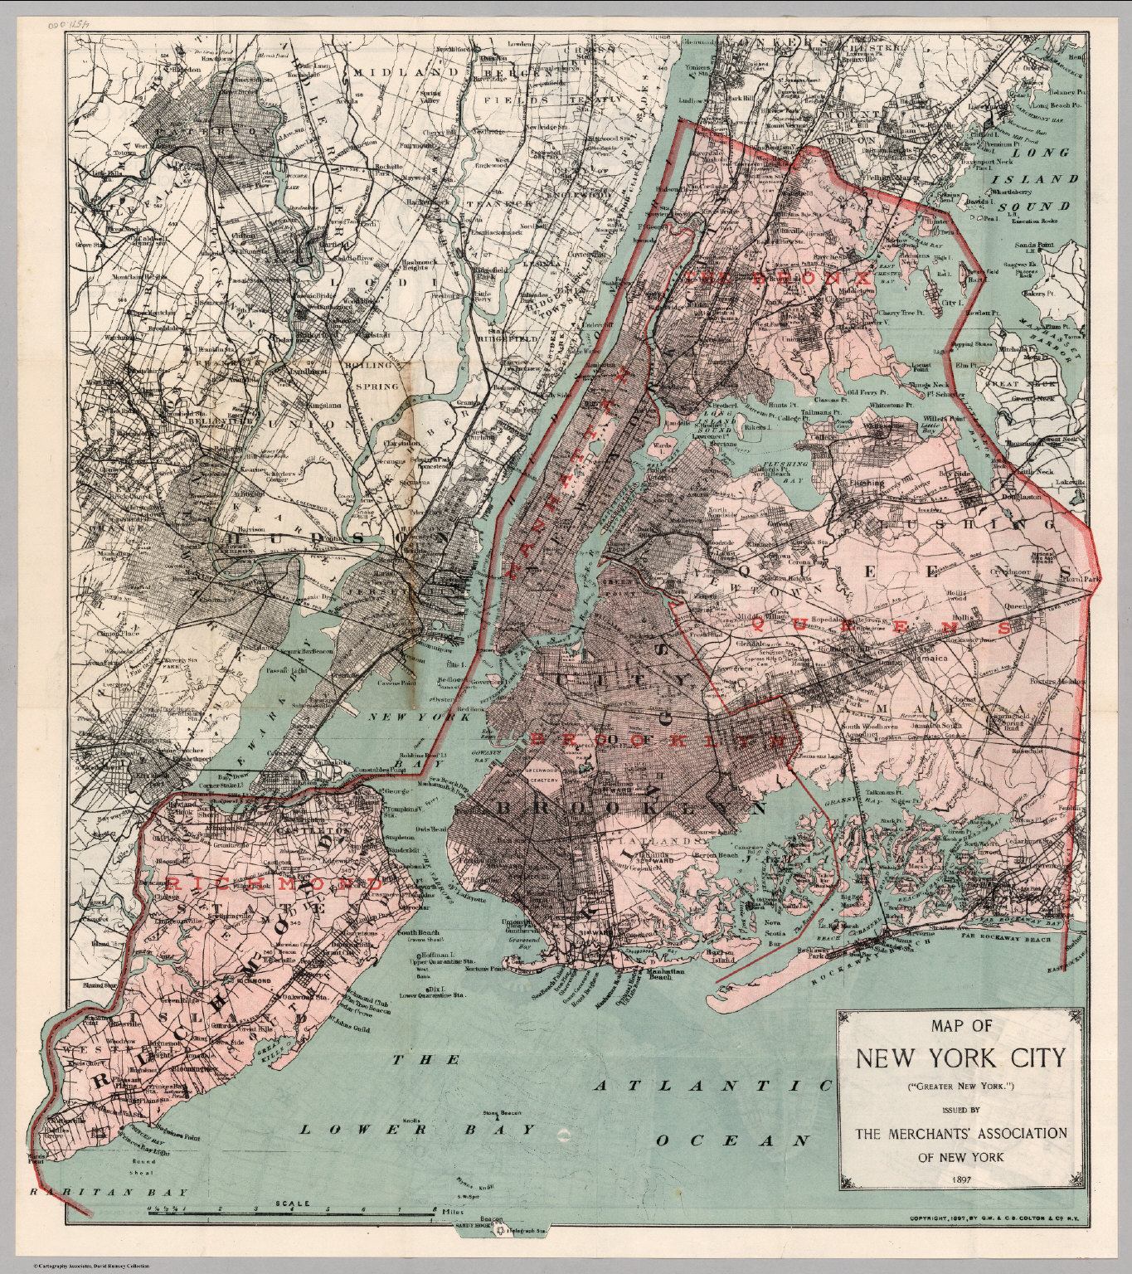
greater-new-york-1897-map
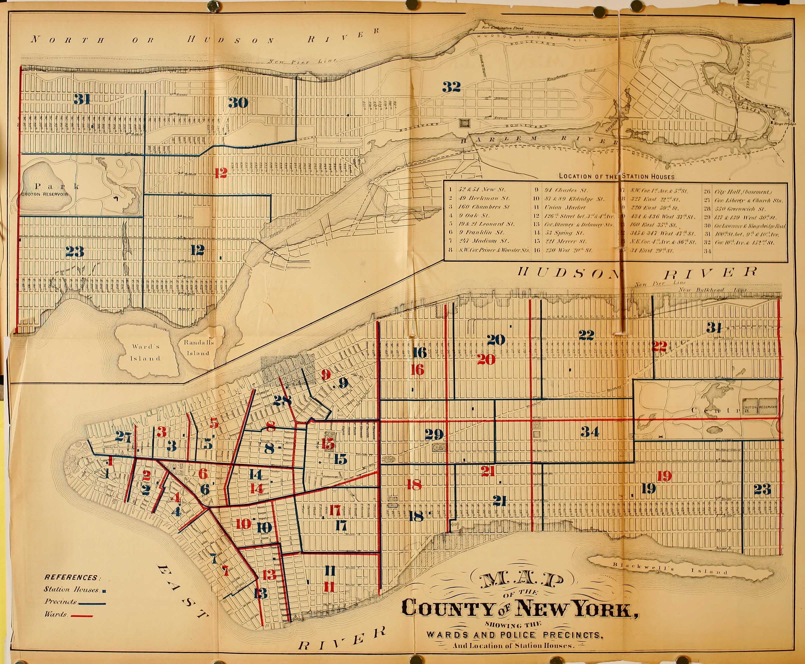
manhattan-wards-1870-map
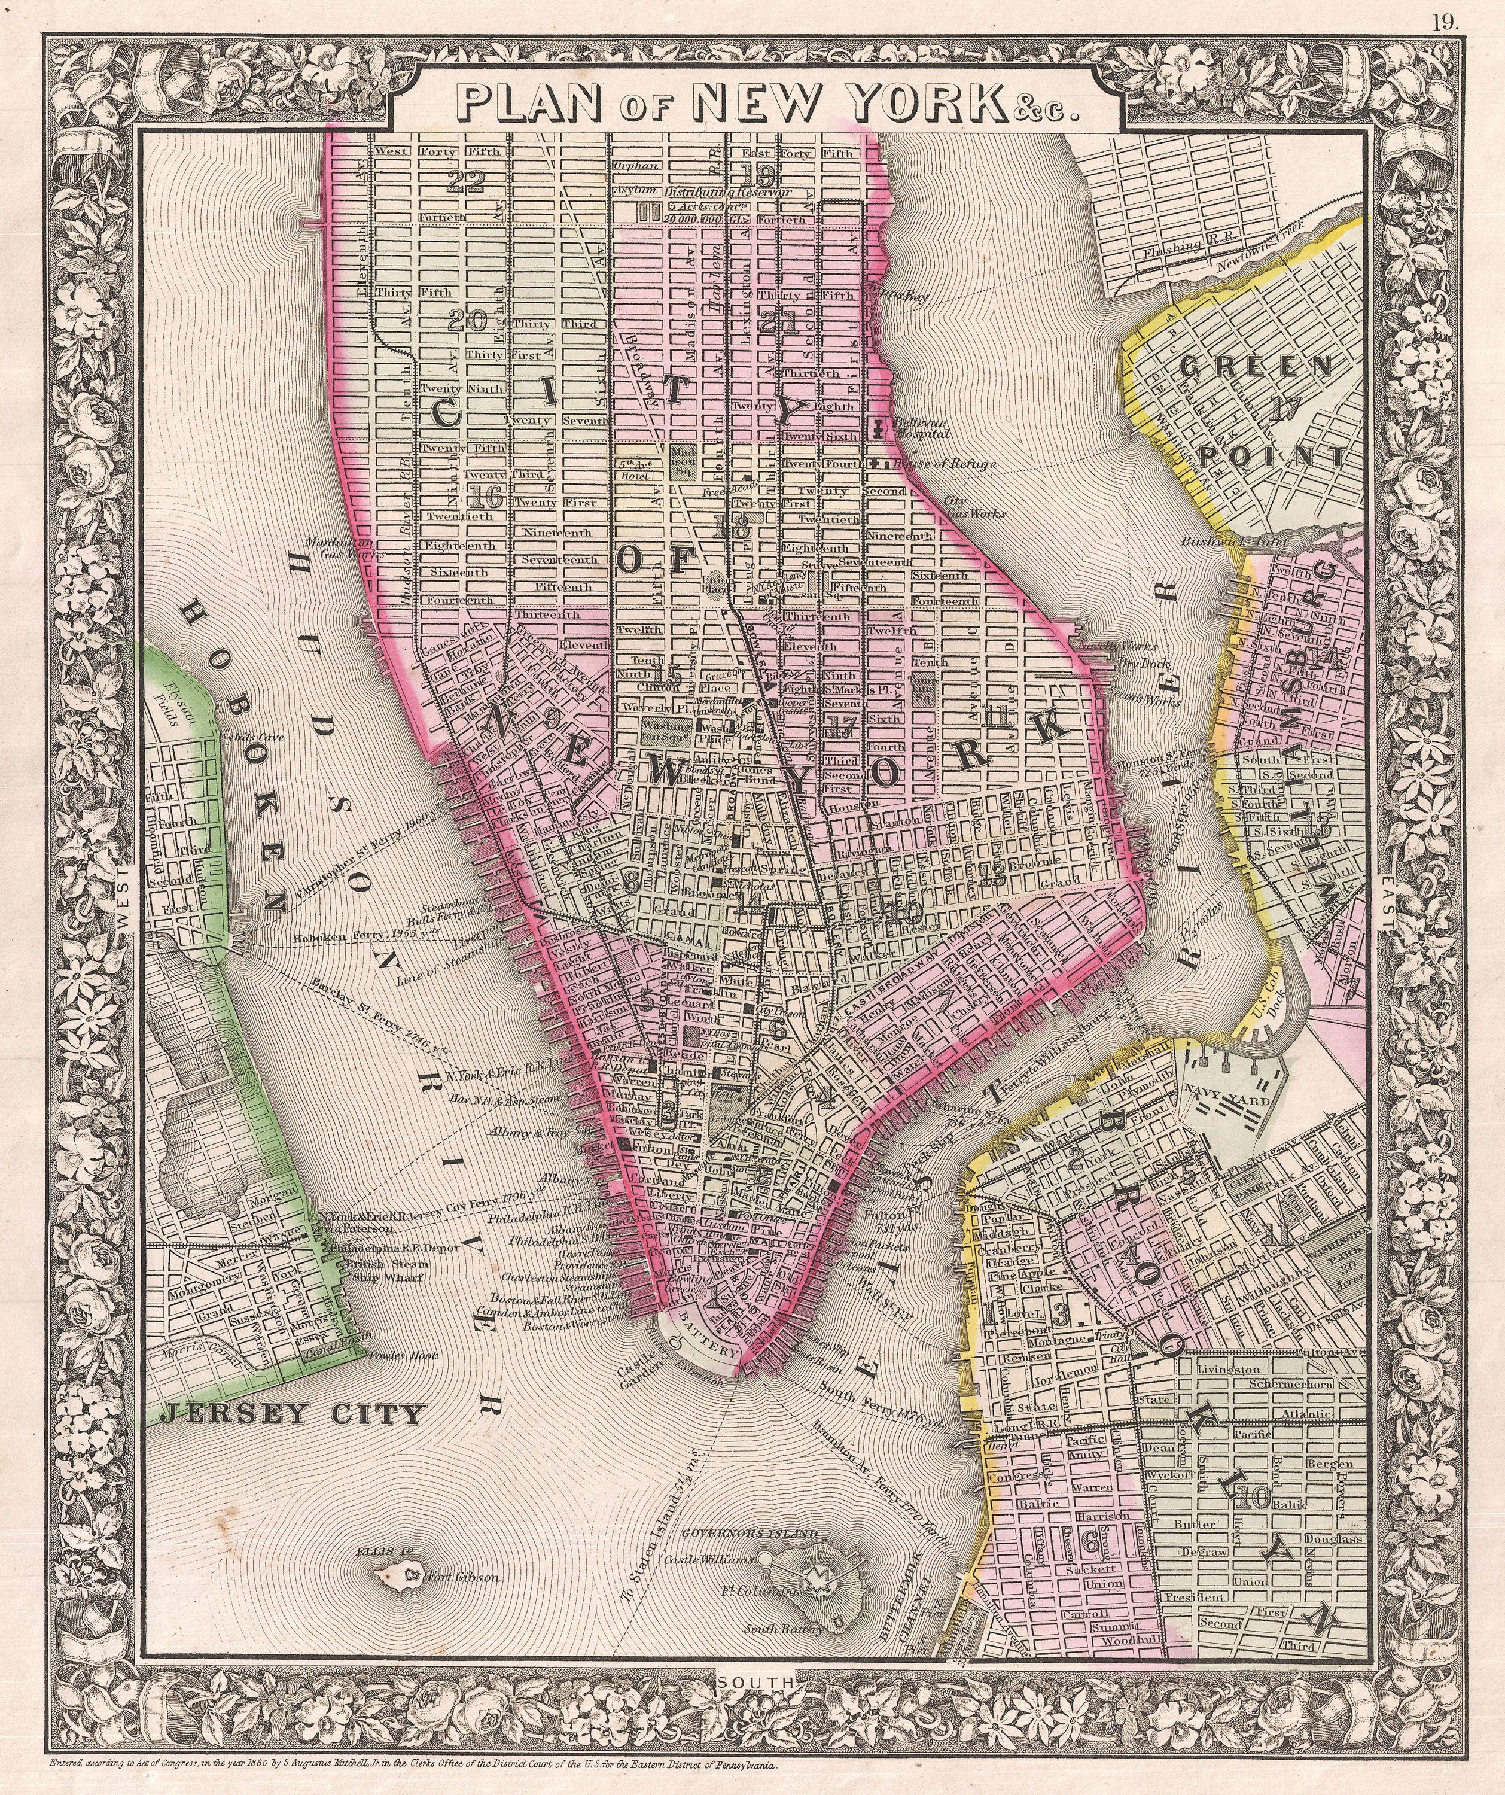
nyc-brooklyn-ward-map-1866-mitchell

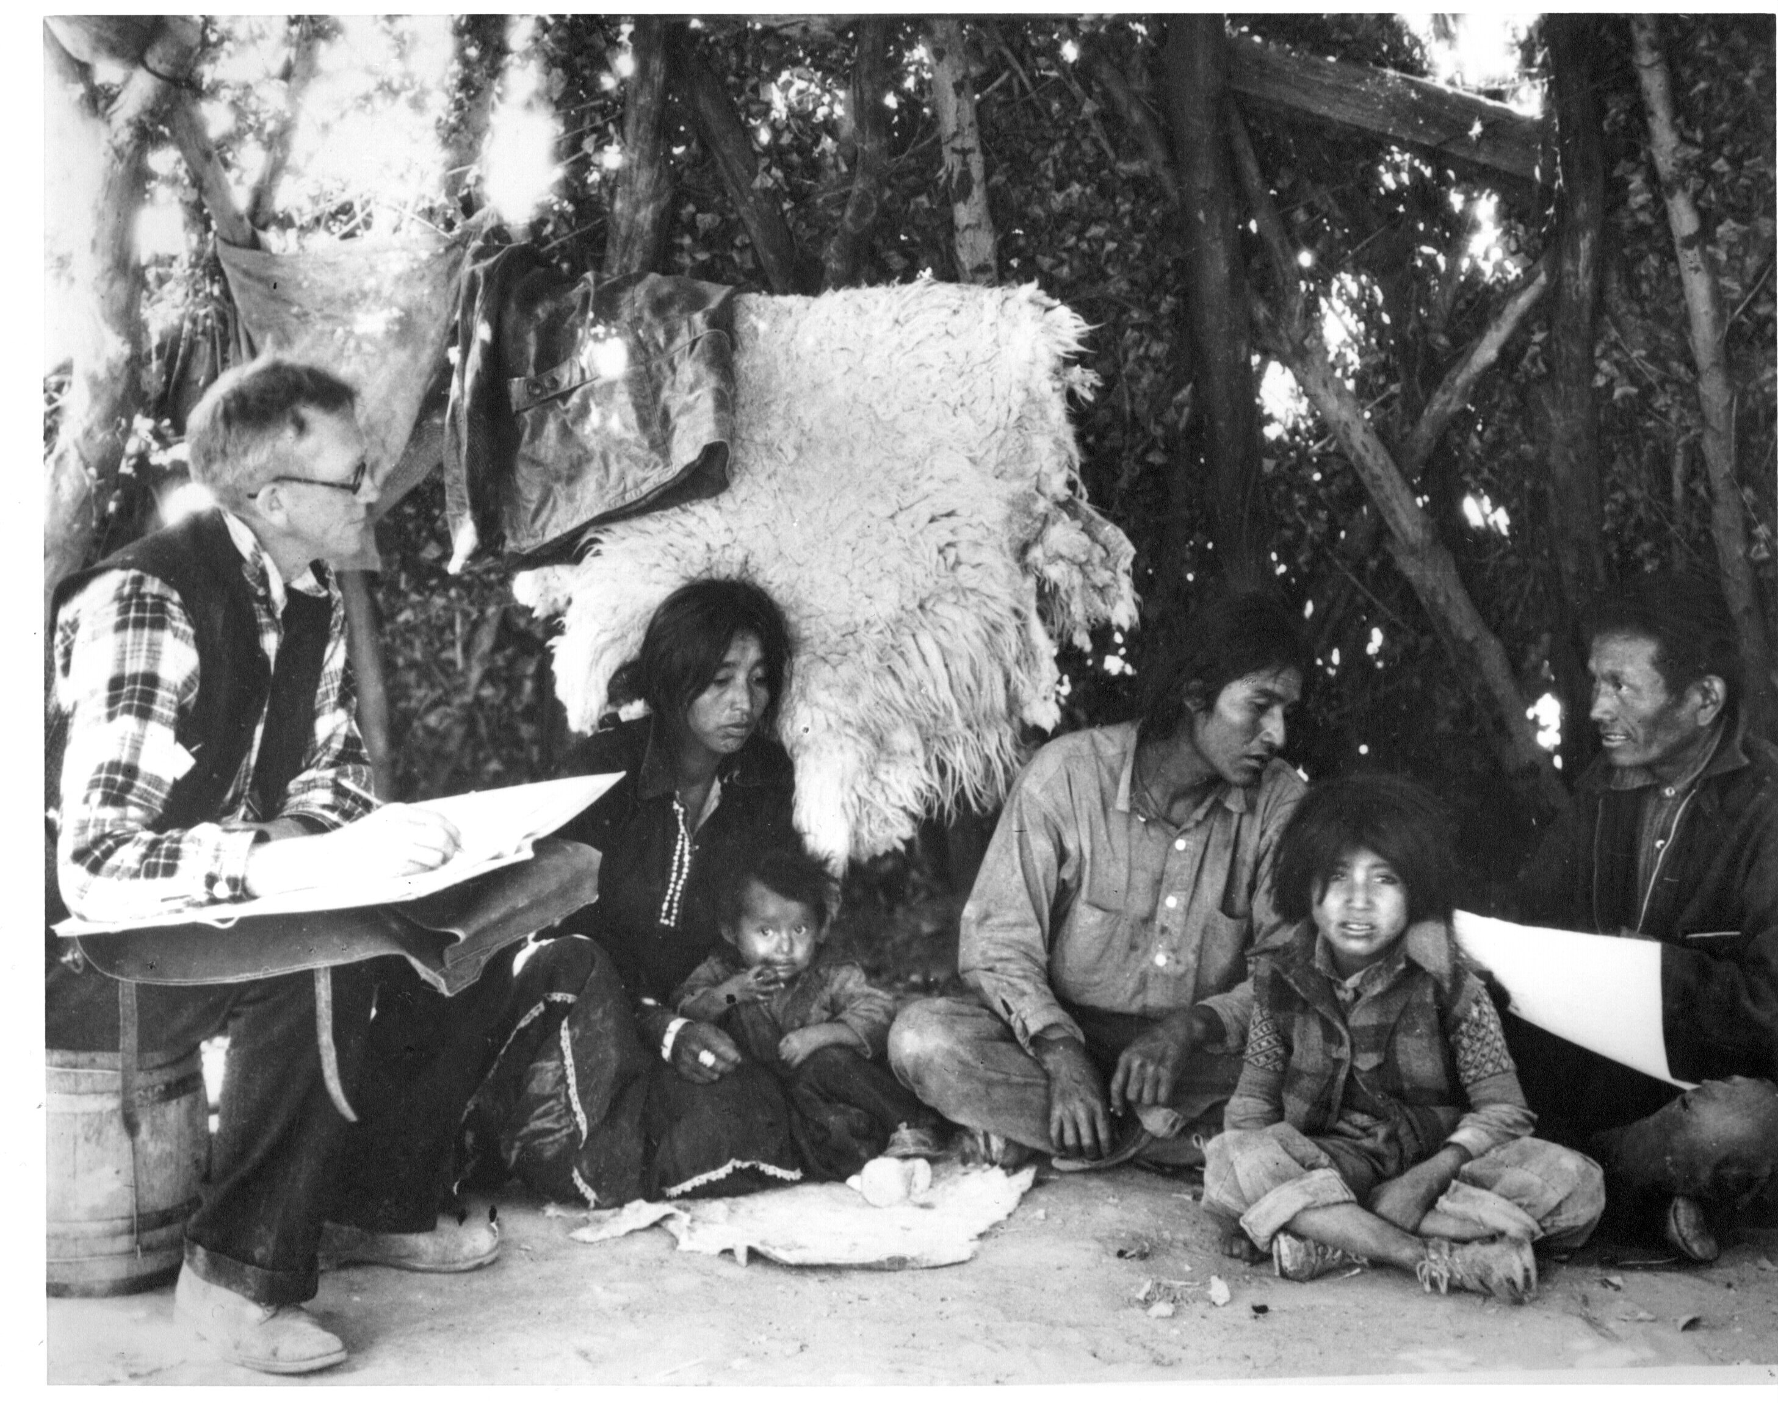
census-enumerator-1930
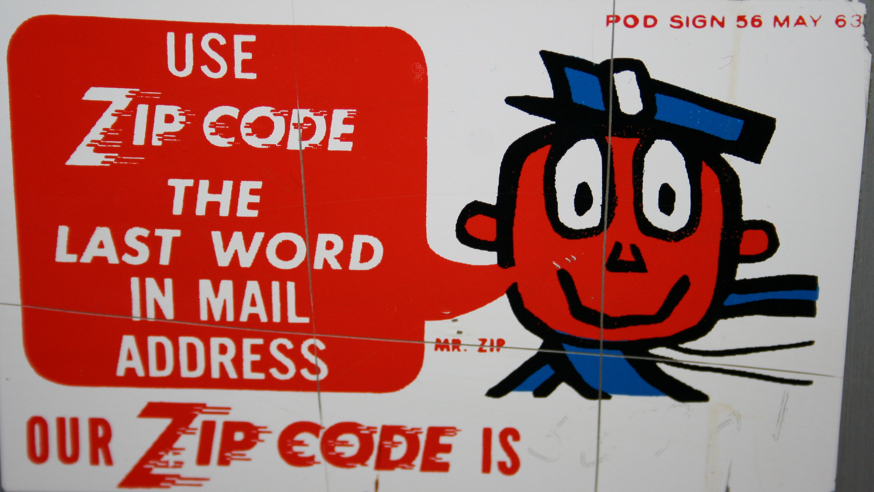
us-zip-code-1963-poster
Method: this Word edition reproduces the source document verbatim and appends the editors' research dossier; layout follows Word conventions rather than the archival PDF design.

