THE REINVENTION OF THE CITY OF NEW YORK
FICTIVE DOCUMENTS ARCHIVE — ENHANCED EDITION

The UN Jurisdiction Claim - Checked Against the Statute
The Lenapehoking Notices
The claim kept in full, then measured against the record: the IOIA's actual text and approval date (December 29, 1945), what the 1947 UN Headquarters Agreement really does, the Supreme Court's Jam v. IFC ruling on IOIA immunity, and where each of the three sentences stops being law.
Word edition — the complete original document verbatim, followed by the editors' research dossier.
EDITOR'S INTRODUCTION
The original document: Received October 13, 2026 - three sentences compressing the file's theory-core: UN Headquarters extraterritoriality, New York City as an international jurisdiction, and the December 9, 1945 IOIA 'legislative coup' that supposedly transferred every U.S. public office.
This enhanced edition reproduces the source document verbatim (its own formatting and images intact), then appends the editors' research dossier with the verified history behind the document's claims. The PDF edition of this research is available on the same page.
THE ORIGINAL DOCUMENT — VERBATIM
Source file: The UN Jurisdiction Claim.docx
But the the U.N. Headquarters is extraterritorial because it is international.

New York City is an international extraterritorial jurisdiction as a result.

on December 9th, 1945, the "legislative coup" executed by the U.S. Congress, transferred every public office of the United States, via the enactment of the International Organization Immunities Act, into the extraterritorial, extrajudicial and extralegal in rem jurisdiction of the UNITED (CHEROKEE) NATIONS. This voluntary capitulation resulted in private Americans being gaslighted by registered or licensed offshore foreign statute merchants into the United Nations or UN’s extralegal in rem jurisdiction(s) to be subjected to their private international treaties or agreements.
THE RESEARCH DOSSIER
The UN Jurisdiction Claim — Research Brief
Source document: raw/The UN Jurisdiction Claim.md (740 bytes, 3 paragraphs — received October 13, 2026 as a chat message from the archive's submitter; the shortest document in the Fictiv file) Exhibit context: keep every word, test every claim.

1. STRUCTURE
Three sentences, three escalating claims:
# | Line | Claim | Type
1 | 1 | The UN Headquarters is extraterritorial "because it is international" | Mixed — narrowly true in part, reasoning wrong
2 | 3 | "New York City is an international extraterritorial jurisdiction as a result" | False — non sequitur from #1
3 | 5 | The Dec. 9, 1945 IOIA enactment was a "legislative coup" that "transferred every public office of the United States" into "the extraterritorial, extrajudicial and extralegal in rem jurisdiction of the UNITED (CHEROKEE) NATIONS" | False — date, mechanism, and effect all contradicted by the record
Genre: the compressed core of the sovereign-citizen "UN jurisdiction" theory that the longer Cluster I documents elaborate. Every load-bearing element also appears in the 202-page compiled record (see united-cherokee-nations.md, §2.B claims 3–5 and §4 red flags).
2. CLAIMS (the document's key factual assertions)
1. UN Headquarters is "extraterritorial because it is international." 2. New York City as a whole is "an international extraterritorial jurisdiction as a result" of the Headquarters' status. 3. On "December 9th, 1945" Congress enacted the International Organization Immunities Act — a "legislative coup" that "transferred every public office of the United States" into the "extraterritorial, extrajudicial and extralegal in rem jurisdiction of the UNITED (CHEROKEE) NATIONS." 4. Private Americans are thereby "gaslighted by registered or licensed offshore foreign statute merchants" into the UN's "extralegal in rem jurisdiction(s)" and subjected to "their private international treaties or agreements."
3. THE RECORD — verified facts, by theme
3.1 The International Organizations Immunities Act (IOIA)
- Enactment date: the statute reads "Approved December 29, 1945" — Public Law 79-291, Chapter 652, 59 Stat. 669 (79th Congress). The claim's "December 9" is a transposition, and a telling one: it appears verbatim in the Avalon Project's online copy of the Act (avalon.law.yale.edu, heading "International Organizations Immunities Act, December 9, 1945" — while the statute text on the same page reads "Approved December 29, 1945"). The theory's citation pipeline evidently runs through the erroneous Avalon heading, not the statute.
- What the IOIA actually does: Title I §1 defines "international organization" as a public international organization in which the United States participates and which the President has designated by Executive Order. §2 grants designated organizations suit/property/procurement capacities and immunity from suit and judicial process as enjoyed by foreign governments, waivable by the organization; property immune from search and confiscation; archives inviolable; tax and customs privileges paralleling foreign governments (with revocation and abuse remedies in §1 and reciprocity provisions in §9). Nothing in the Act transfers sovereignty, offices, or jurisdiction; it is a privileges-and-immunities statute for organizations like the UN, on the model of diplomatic immunity law.
- Who it binds: designated organizations, their officers and employees, and foreign representatives to them. It says nothing about "every public office of the United States," nothing about in rem jurisdiction, and nothing about private Americans.
- The modern construction: in Jam v. International Finance Corp. (No. 17-1011, Feb. 27, 2019), the Supreme Court held IOIA immunity is restrictive — coextensive with the Foreign Sovereign Immunities Act, covering only commercial-activity-adjacent suits, not blanket "extralegal" status. International organizations can be and are sued in U.S. courts for their commercial acts.
3.2 The UN Headquarters' actual status
- The Headquarters district (Turtle Bay, 17–18 acres, 760 United Nations Plaza) is administered solely by the UN under the 1947 Headquarters Agreement (61 Stat. 756, T.I.A.S. 1676) between the UN and the U.S. — not by the IOIA.
- The land is U.S. land: purchased with an $8.5M Rockefeller donation, and the Agreement itself contemplates U.S. law — it was concluded as a treaty with Congressionally approved legislation (P.L. 80-357). Section 25 makes federal, state and local law applicable in the district except as the UN otherwise provides; the U.S. retains criminal jurisdiction through a "federal district" mechanism (Agreement §9(a)) enabling U.S. enforcement of a compact area under federal, not New York State, jurisdiction.
- The popular shorthand "extraterritorial" (used even by Wikipedia's Headquarters article) describes administrative inviolability of the premises — the UN controls its premises, and the U.S. agreed not to enter to enforce its law without UN consent. It is the same status as an embassy compound: not a cession of sovereignty, not foreign territory, and emphatically not a status attaching to New York City outside the fenced district.
- Court treatment: in United States v. Melekh, 1995 WL 532961 (2d Cir. 1995) (unpub.), the Second Circuit rejected the argument that the UN Headquarters area is "not subject to the jurisdiction of the United States" for immigration purposes — an argument drawn from the same theory-family as this document. UN Headquarters is not a law-free zone: U.S. courts, FBI and NYPD operate under the Headquarters Agreement framework, and the Organization itself enjoys only waivable, restrictive immunity.
3.3 "UNITED (CHEROKEE) NATIONS" and the in-rem theory
- The 202-page compiled record (Cluster I) asserts the same chain with the CFR citation dressed up: "New York City is defined in the Federal Regulations as the United Nations. See 20 C.F.R chapter 111, subpart B 422.103 (b)(2)(2)." That provision is a Social Security Administration field-office address listing — it lists the SSA office at 77th St. in the UN plaza ZIP — not a definition of New York City. (Verified in united-cherokee-nations.md §2.B.3.)
- "United Cherokee Nations" is not a federally recognized tribe. Federally recognized Cherokee governments are the Cherokee Nation, the United Keetoowah Band (both in Oklahoma), and the Eastern Band (NC). Self-styled "United Cherokee Nation" entities are state-registered or unregistered organizations whose instruments courts have repeatedly declined to treat as sovereign (see united-cherokee-nations.md §3.3).
- "In rem jurisdiction over every public office" inverts real law: in rem jurisdiction is jurisdiction over property (or statuses) at a location — a doctrine of U.S. courts, not a transferable "zone" Congress can hand to an international body. No statute, treaty or case moves U.S. public offices into any UN or Cherokee-national jurisdiction. The IOIA in fact runs the other direction — it exposes international organizations to U.S. suit (post-Jam) rather than moving U.S. offices out of it.
3.4 "Gaslighted by statute merchants"
"Statute merchant" is a genuine medieval English debt-register institution (Statutum Mercatorum, 1283) — real history, deployed here as a label for licensed professionals. The rhetorical move (real term, wrong century, no legal effect) matches the pattern catalogued in the compiled-record brief: accurate black-letter fragments carrying a sovereign-status conclusion they do not support.
4. RED FLAGS — pseudo-legal / sovereign-citizen markers
- Capitalization mysticism: "UNITED (CHEROKEE) NATIONS" as a distinct entity from the words' meaning — the classic straw-man/ALL-CAPS lineage.
- "Extralegal / extrajudicial zone" theory: the claim requires a law-free jurisdiction no U.S. court has ever recognized; Melekh and the Headquarters Agreement's own text foreclose it.
- Date error inherited from a transcription: "December 9, 1945" traces to the Avalon Project's mislabeled heading, demonstrating citation-layer (not primary-source) research.
- Secret-transfer narrative: "legislative coup ... transferred every public office" has no textual hook in the IOIA — the Act's plain text is a short privileges statute, reproduced in the enhanced edition below.
- In rem confusion: treats a property-jurisdiction doctrine as a geographic "zone" that can swallow a city.
5. WHAT'S REAL — accurate history worth preserving, with better sourcing
- The UN Headquarters really is a special zone: sole UN administration, agreed U.S. non-entry for enforcement, and service arrangements with NYC — the accurate version of claim #1, sourced to the 1947 Headquarters Agreement (61 Stat. 756) rather than "because it is international."
- The IOIA really is a sweeping-sounding statute that grants real immunities — to designated organizations and their staffs, revocable by the President, restricted by Jam. The accurate statement of claim #3's kernel.
- The UN really was the UN's headquarters-site runner-up consideration involving NYC land assembled by the Rockefellers and William Zeckendorf — verifiable city history (see the Headquarters history in lenapehoking.md context and the exhibit's EP1–EP8 sources).
- "Statute merchant" is a real legal-historical institution (1283 England) worth an honest sidebar, decoupled from the claim.
6. IMAGES
- un-headquarters-nyc — UN Headquarters, Turtle Bay (per images/manifest.json): the actual "extraterritorial" acreage — 17–18 acres of it, not 300 square miles of city.
- us-code-law-book — the IOIA as codified at 22 U.S.C. §288 et seq.: a privileges statute, not a jurisdiction transfer.
- constitution-article-iii — the judiciary the "extrajudicial" claim has to disappear.
Summary verdict
Three sentences, three claims: the first is one-third true for the wrong reason (Headquarters premises are inviolable under the 1947 Headquarters Agreement — "extraterritorial" is shorthand, and it covers a fenced district, not a city); the second is a non sequitur (nothing about the Headquarters' status propagates to New York City); the third is false in every element — wrong date (the Act was approved December 29, 1945, and the "December 9" traces to a mislabeled Avalon Project page), wrong mechanism (a privileges-and-immunities statute for designated international organizations, revocable by the President and narrowed by the Supreme Court in Jam v. IFC), and wrong effect (no public office, person or thing was "transferred" anywhere; United States v. Melekh confirms U.S. jurisdiction persists at the Headquarters itself). The document is a faithful miniature of the Cluster I theory-core: real terms, wrong combinations, no legal effect.


us-code-law-book
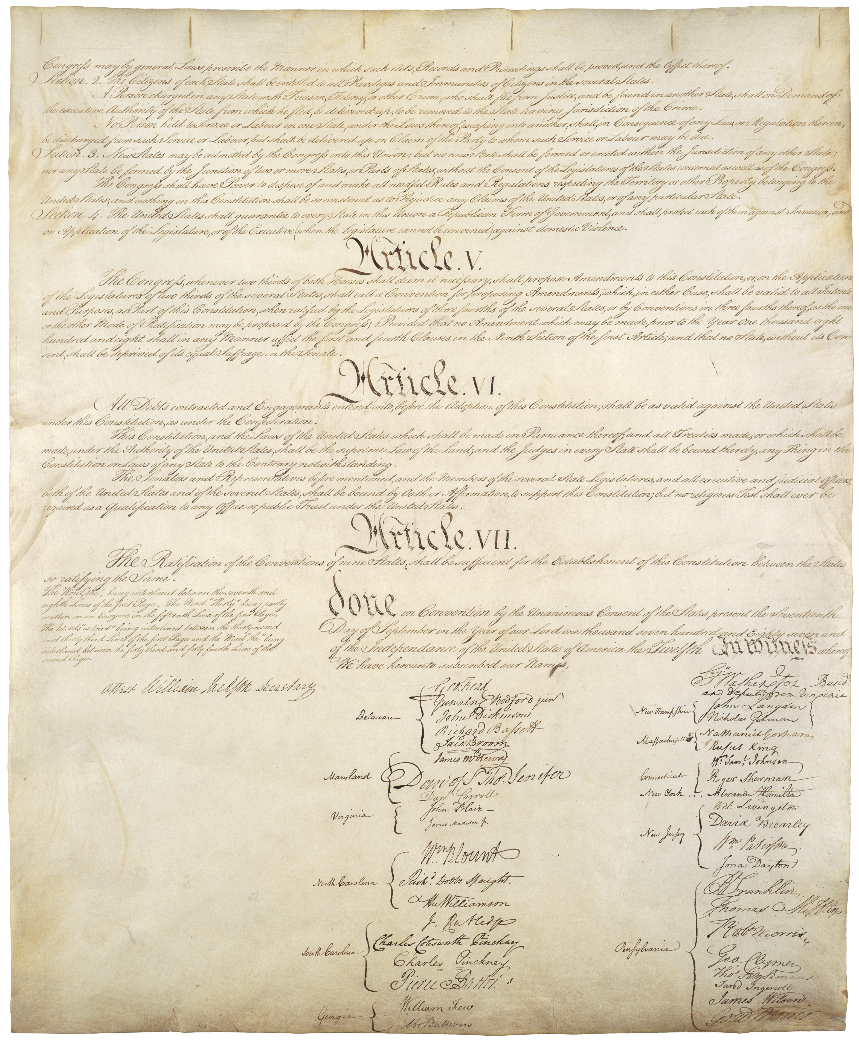
constitution-article-iii
Method: this Word edition reproduces the source document verbatim and appends the editors' research dossier; layout follows Word conventions rather than the archival PDF design.

