Boundaries, Districts, and Zones in New York City: Census Boundaries
Census Boundaries - Boundaries, Districts, and Zones in New York City - Research Guides at New York Public Library Research Centers
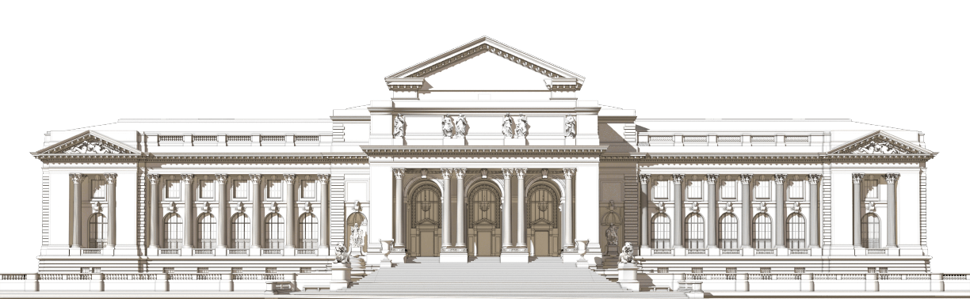
© The New York Public Library, 2026

The New York Public Library is a 501(c)(3) | EIN 13-1887440
This guide covers how to find cartographic materials related to the internal boundaries, districts, and zones of New York City.
- About
- Using Our Catalogs
- Census Boundaries
- Political Districts
- Buildings
- Neighborhood Services
- Emergency Services
- Historic Districts
- Redlining in NYC
- Environmental and Health Hazard Zones
Census Boundaries
Many types of research topics - such as genealogy, demographic studies, city planning, policy analysis, and urban planning - will require you to decipher or locate historical census boundaries that are referred to on census records. These boundaries include wards, assembly districts, election districts, or enumeration districts.
When using maps to get a better understanding of these referred boundaries on census records, some questions you can answer include:
- Where was this person living, in the context of New York City and their neighborhood?
- How was the city separated into various districts, and why? Does it change over time?
- What does the census data tell us about a specific neighborhood?
Before we can find maps that answer these types of questions, please see below for a brief explanation of the census numbering system(s).
Quick Links to Each Section on Page:
Defining ED, AD/ED, and Wards in the Context of the Census | Wards | Election Districts | Enumeration Districts | Assembly Districts
Defining ED, AD/ED, and Wards in the Context of the Census
ED in the 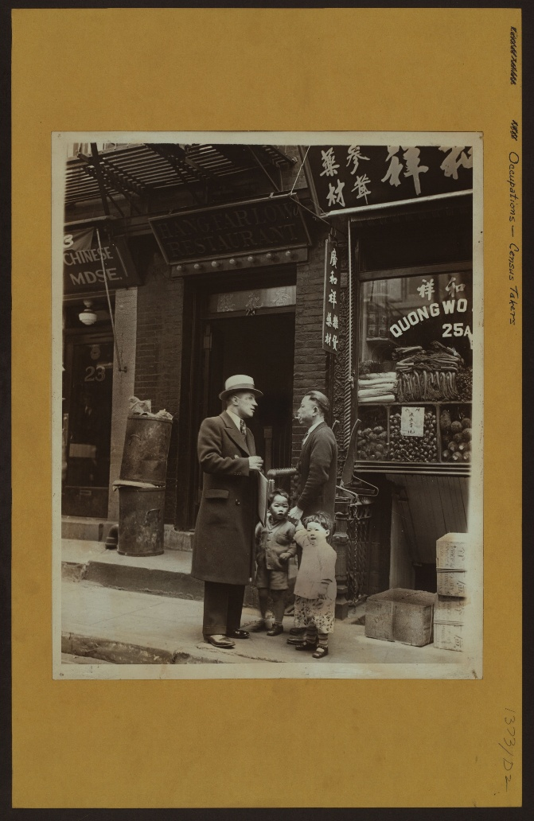
Federal Census:
You will be interested in an ED number, which is also also known as an Enumeration District. According to the National Archives, an enumeration district "was an area that an enumerator (census taker) could completely cover within two weeks in cities and within four weeks in rural areas."
On these census records, the ward that was covered is also denoted.
AD & ED in the NYS Census:
The New York State census utilized an AD/ED pair. In these cases:
- AD = Assembly District
  - Assembly Districts are further subdivided into Election Districts.
- ED = Election District
  - Not to be confused with the federal census' ED (Enumeration District).
These AD/ED pairs are the equivalent of the federal census' enumeration districts.
These pairs were used for:
- 1890 Police Census
- 1892 New York State Census (the AD number in this AD/ED pair refers to Ward)
- 1905 New York State Censuses
- 1915 New York State Censuses
- 1925 State Censuses
Please see below for ways to find enumeration district maps, assembly district maps, ward maps, and election district maps.
And, if you are interested in seeing how data collected from the census is incorporated into maps today, check out the following United States Census Bureau pages:
- Interactive Maps
- Tables & Maps
- Reference Maps
Lastly, if you are interested in conducting census-related research, we do recommend contacting the Irma and Paul Milstein Division of United States History, Local History and Genealogy at history@nypl.org for any questions you might have.
Source: Stephen Morses' Obtaining AD/ED for the 1890-1925 New York State Census in One Step: Frequently Asked Questions.
Image Source: Occupations - Census takers. 1930. NYPL Digital Collections Image ID 732277F
Wards
- Finding Maps
- Selection of Maps at NYPL
- Additional Resources and Databases
When using the Online Research Catalog:
- In the Advanced Search function, checkmark "Cartographic" under Format.
- We recommend the following keyword searches:
  - Wards [borough name]
  - Wards New York City
In some insurance atlases, the index plate and/or plates will indicate the locations of ward and ward boundaries. For example, when looking at Atlas of the borough of Brooklyn, City of New York : the first twenty eight wards complete in four volumes from 1903-1909:
- In the key of the Index Plate that the ward numbers are indicated in each plate by triangles and red lines for each ward's boundaries.
- Using Plate 1 as an example, you can see (based on the plate's title) that Wards 1, 2, & 4 are represented on this plate. In turn, you can see the triangles and red lines that depict the ward numbers and boundaries on this plate.
To learn more on how to search for these types of insurances atlases, please go to the Insurance Atlases: Blocks, Lots, and Property Boundaries section of Buildings page.
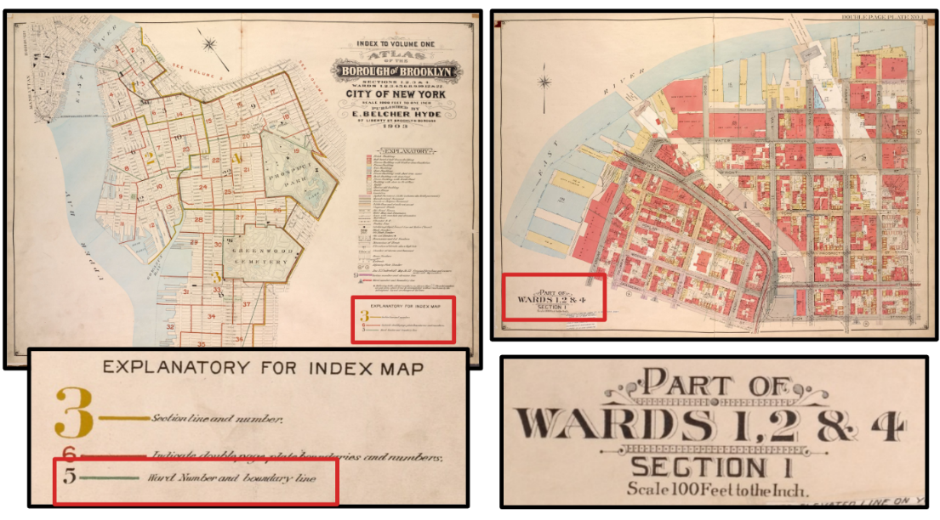
Image Source: Atlas of the borough of Brooklyn, City of New York : the first twenty eight wards complete in four volumes.1903-1909. NYPL Digital Collections Image ID 1695478 and 1695479
Election Districts
- Finding Maps
- Selection of Maps at NYPL
- Additional Resources and Databases
When using the Online Research Catalog:
- In the Advanced Search function, checkmark "Cartographic" under Format.
- We recommend the following keyword searches:
  - Election District [borough name]
    - Example: Election District Brooklyn
  - Election District New York City
  - Subject: New York (State) Legislature Election districts Maps
For maps of current election districts in New York City, please refer to the following resources:
- Maps on the Maps & Geography page of NYC's Planning Website:
  - Can be used to determine which district number is relevant to your region of interest, in relation to State Assembly, City Council, and State Senate.
- "Current NYC District Maps" on the Board of Elections in the City of New York.
  - Maps are organized by borough and then by election type/district number.
  - Please note that "New York City" is referring to districts in Manhattan.
  - Said maps also include locations of polls.
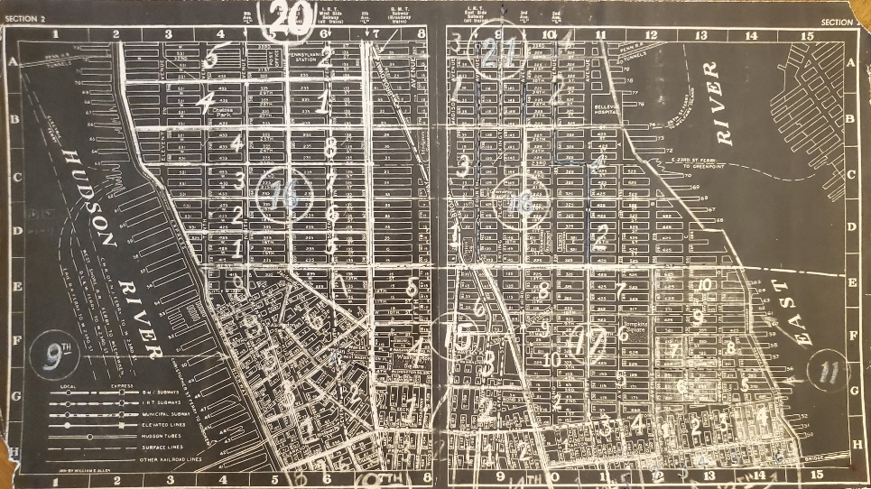
Image Source: Map from New York City voting places, 1855 / Gertrude A. Barber. [1855?] Map Div.+ (New York City. 1855) (New York City voting places, 1855)
Enumeration Districts
- Finding Maps
- Selection of Maps at NYPL
- Additional Resources and Databases
When using the Online Research Catalog:
- In the Advanced Search function, checkmark "Cartographic" under Format.
- We recommend the following keyword searches:
- Subject: Census districts New York (State) New York Maps
- Keyword Search: Enumeration District [borough name]
  - Example: Enumeration District Staten Island
- Keyword Search: Enumeration District New York City
Additional resources that have digitized enumeration district maps can be found at the National Archives' collection Enumeration District and Related Maps, 1880–1990:
- To see the records, click "Search Within Set"
- You can type in the region of interest in the search bar.
- On the results page, using the filter panel on the left, you can choose:
  - to see all the records, including those that have not been digitized.
  - only include the records that have been digitized.
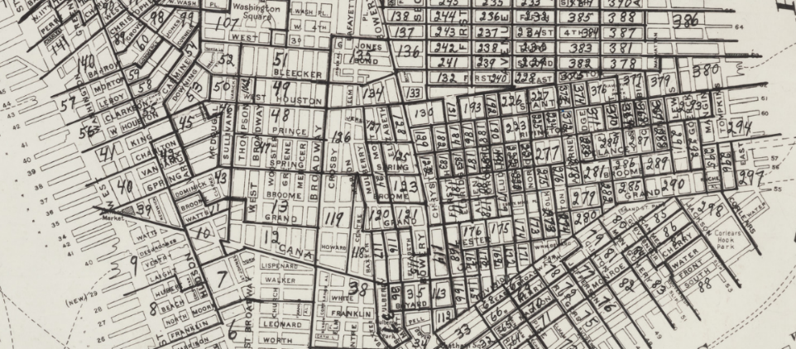
Image Source: Excerpt from [Map of 1900 census enumeration districts for Manhattan and the Bronx / prepared by Barbara Hillman]. NYPL Digital Collections Image ID 56738463
Assembly Districts
- Finding Maps
- Selection of Maps at NYPL
- Additional Resources and Databases
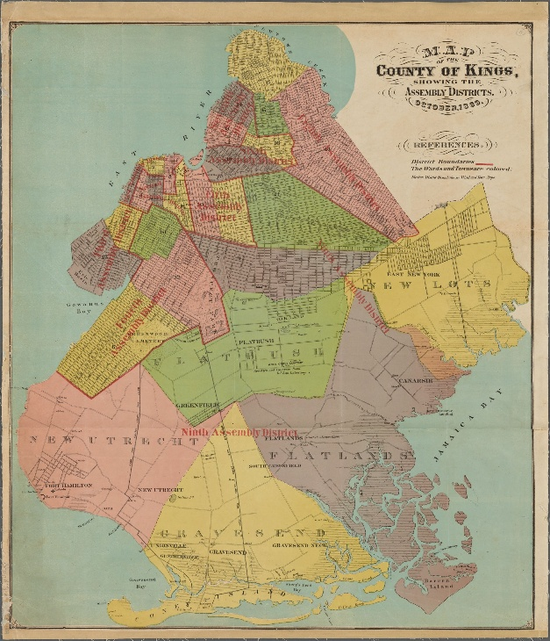
When using the Online Research Catalog:
- In the Advanced Search function, checkmark "Cartographic" under Format.
- We recommend the following searches:
  - Keyword: Assembly District [borough name]
    - Example: Assembly District Manhattan
  - Keyword: Assembly District New York City
  - Subject: New York (State) Legislature Assembly Election districts Maps
  - Subject: New York (State) Legislature Assembly Maps
For maps of current assembly districts in New York City, please refer to the following resources:
- "State Assembly District Maps by Borough" on the Maps & Geography page of NYC's Planning Website:
  - Can be used to determine which district number is relevant to your region of interest.
- "Current NYC District Maps" on the Board of Elections in the City of New York:
  - Maps are organized by borough and then by election type/district number.
  - Please note that "New York City" is referring to districts in Manhattan.
  - Said maps also include locations of polls.
Image Source: Map of the county of Kings, showing the Assembly districts, October 1869. [1869]. NYPL Digital Collections Image ID 4056204.

History
Brooklyn's Forgotten Electoral Districts: The Lost History of the Ward System
There are invisible, forgotten lines dividing Brooklyn in the form of the borough’s long unused ward system, an early version of today’s assembly and electoral districts.

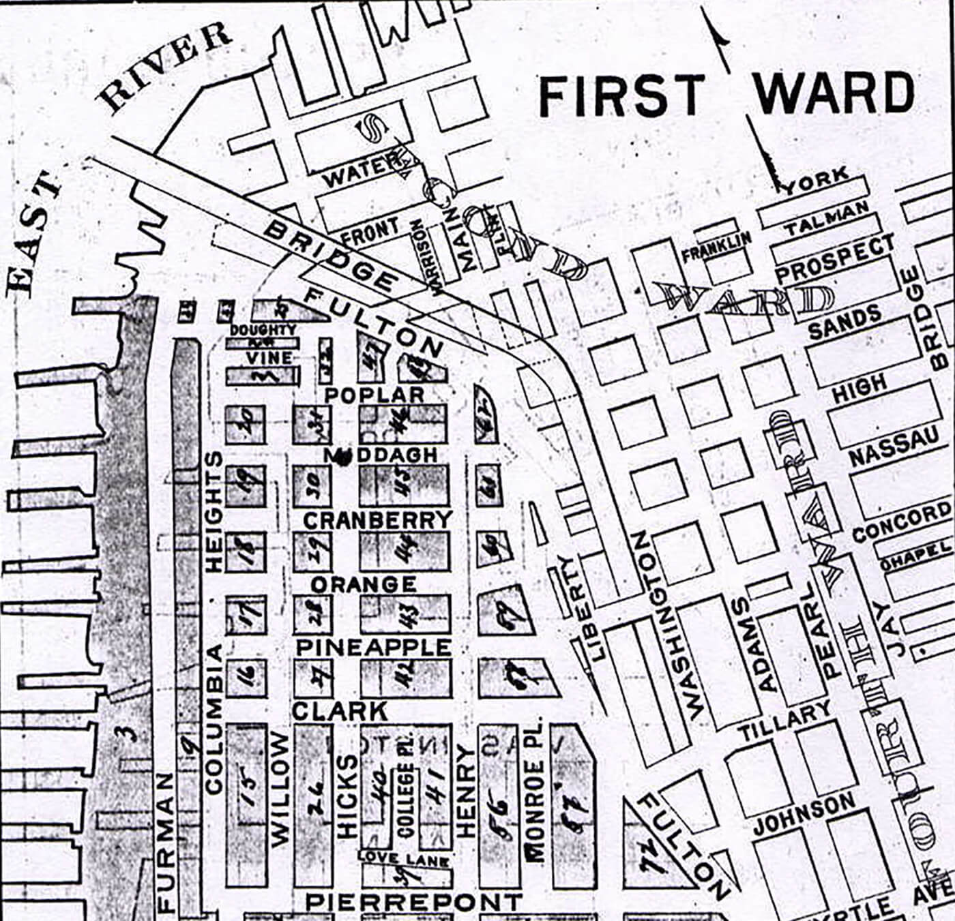
An 1893 map of Brooklyn Heights, Brooklyn’s first ward. Map via Brooklyn Genealogy
by Hannah Frishberg
05/17/20160Share
There are invisible, forgotten lines criss-crossing Brooklyn, long-lost borders dividing the borough into a series of numbered neighborhoods: Brooklyn’s wards.
Wards are the historic equivalent of today’s electoral districts: boundaries used in elections to designate voters to certain areas.
Some U.S. cities have maintained at least a portion of their ward designations — like New Orleans with its Katrina-decimated Ninth Ward, or Houston and its six historic wards — but Brooklyn today has only the barest reminders of its ward-divided past. One of the last hints of this history is the now-defunct 3rd Ward art space that once operated in East Williamsburg.
Brooklyn in Your Inbox
Stay up to date with more great news and articles like this one.

Sign Up

Yet, wards once played an outsized role in Brooklyn’s politics, representing voting districts and changing their borders and quantity to match Brooklyn as it grew.
In 1839, Brooklyn had nine wards. By 1898, that number had boomed with the city’s population to 32.
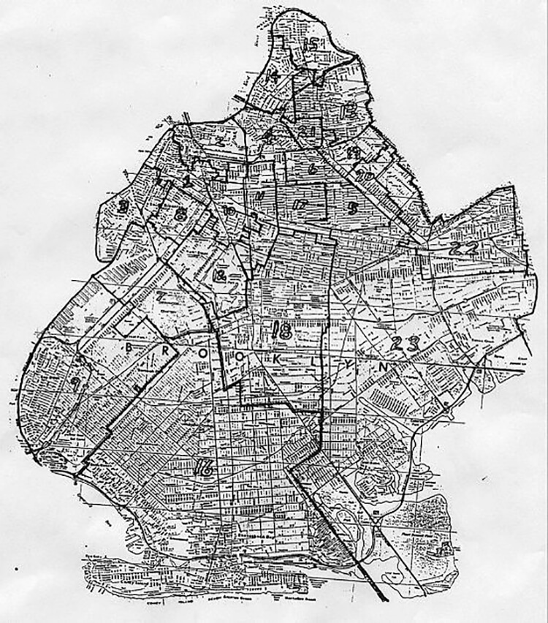A ward map of Brooklyn in 1915. Map via Brooklyn Genealogy
In 1915, Bed Stuy composed the 23rd and part of the 7th and 9th wards, Greenpoint was spread out over wards 8, 14, 15 and 17, and Brooklyn Heights was contained in wards 1 and 3, maps show.
The wards were very confusing, not seeming to follow any logical gridded boundary or numbering system, subdividing as Brooklyn’s population grew.
Even the papers seemed to have a hard time keeping up: “Gravesend Is in Now,” reads a Brooklyn Daily Eagle headline from 1894, “New Utrecht Will Follow in July. Flatlands Must Wait Until January 1, 1896.”
Counterintuitively, Gravesend was made the 31st ward before New Utrecht was made the 30th.
The Daily Eagle article goes on to explain the reason for the staggering of ward initiations was because of complications with the constitutional debt limit, a constraint concept that still exists today and limits the amount of debt a local government is allowed to incur.
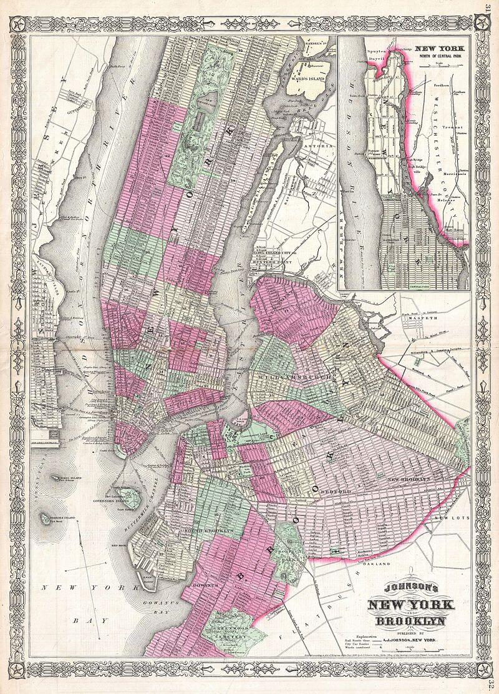An 1866 map showing the ward borders in both Brooklyn and Manhattan. Map via Wikipedia
Brooklyn stopped using wards in the early 20th century, and the system was formally abolished in 1938 according to Brooklyn Genealogy.
It took time for the term to leave the popular vocabulary, however. After the ward system was abandoned, electoral districts and assembly districts took its place.
Today, Brooklyn has 21 assembly districts.
Related Stories
5 of Brooklyn’s Worst Disasters, From the Subway to the Sky
A Sandhog Recalls Being Shot Out of a Brooklyn Heights Subway Tunnel
Demolished, Abandoned or Repurposed: Remembering Brooklyn’s Lost Subway Stations
Email tips@brownstoner.com with further comments, questions or tips. Follow Brownstoner on Twitter and Instagram, and like us on Facebook.

